# Descriptive Statistics – New religious Sermon Dataset

The descriptive statistics below include the two following variables:

* **Absolute coverage**: The raw number of sermons coming from a certain feature
* **Relative Coverage:** Represents the percentage of observations in each category relative to the total number of observations across all categories.
* **Relative Coverage adjusted**: The Adjusted Relative coverage is the proportion of observations in a category, adjusted by that category’s population share. For example, relative coverage for each U.S. state is calculated by dividing the state’s Relative coverage by its proportion of the total U.S. population.

Note: Both the relative coverages are expressed as percentages.

Table of Contents

Descriptive Statistics – New religious Sermon Dataset 1

1 Coverage Variables 3

1.1 Coverage by Year 3

1.2 Coverage by State 4

1.3 Coverage by Denomination of Sermon 5

1.4 Coverage by Religious Family 6

2 Tabulation of Variables 10

2.1 Tabulation of star rating: 10

2.2 Tabulation of Binned Views: 10

2.3 Tabulation of Binned Sermons Contributed: 10

3 Exhibits: 11

3.1 State: Relative Coverage 11

3.2 State: Adjusted Relative Coverage 11

3.3 Election-Related Words 12

3.4 Presidential Election Candidates’ Mentions 17

3.5 RDD-Style Graphs: Sermon Count and View Count 21

4 Pastor-Level Controls 24

4.1 Married0 24

4.2 Children0: 25

4.3 Edu theology0: 32

4.4 Edu theological0: 34

4.5 Edu0: 35

4.6 Denom_index: 37

4.7 Family_index: 38

4.8 Exp bin: 38

## Coverage Variables

### Coverage by Year

|  |  |  |
| --- | --- | --- |
| **Year** | **Absolute Coverage** | **Relative Coverage** |
| 2000 | 2470 | 1.488 |
| 2001 | 6776 | 4.104 |
| 2002 | 8295 | 5.133 |
| 2003 | 8084 | 4.953 |
| 2004 | 7413 | 4.514 |
| 2005 | 8207 | 5.001 |
| 2006 | 9043 | 5.572 |
| **2007** | **11006** | 6.698 |
| 2008 | 9708 | 5.934 |
| 2009 | 8392 | 5.117 |
| 2010 | 6682 | 4.085 |
| 2011 | 7100 | 4.333 |
| 2012 | 6381 | 3.879 |
| 2013 | 6046 | 3.698 |
| 2014 | 6312 | 3.821 |
| 2015 | 5447 | 3.293 |
| 2016 | 4945 | 2.988 |
| 2017 | 4245 | 2.582 |
| 2018 | 5252 | 3.176 |
| 2019 | 4942 | 2.987 |
| 2020 | 4868 | 2.975 |
| 2021 | 5574 | 3.383 |
| 2022 | 8417 | 5.091 |
| 2023 | 5331 | 3.234 |
| 2024 | 3197 | 1.954 |

The highest absolute (and relative) coverage of sermons is from the year 2007, while the lowest percentage of sermons is from the year 2000.

### Coverage by State

|  |  |  |  |
| --- | --- | --- | --- |
| **State** | **Absolute Coverage** | **Relative Coverage** | **Adjusted Relative Coverage (Relative coverage / Percent population in state)** |
| Alabama | 5275 | 3.214 | 2.034 |
| Alaska | 629 | 0.383 | 1.72 |
| Arizona | 4025 | 2.452 | 1.345 |
| Arkansas | 3272 | 1.994 | 2.099 |
| California | 6073 | 3.7 | 0.307 |
| Colorado | 2111 | 1.286 | 0.842 |
| Connecticut | 317 | 0.193 | 0.16 |
| Delaware | 189 | 0.115 | 0.414 |
| Florida | 10161 | 6.191 | 1.09 |
| Georgia | 6904 | 4.205 | 1.446 |
| Hawaii | 164 | 0.1 | 0.232 |
| Idaho | 412 | 0.251 | 0.546 |
| Illinois | 6745 | 4.109 | 0.931 |
| Indiana | 7589 | 4.624 | 2.14 |
| Iowa | 1759 | 1.072 | 1.031 |
| Kansas | 3751 | 2.285 | 2.392 |
| Kentucky | 5144 | 3.134 | 2.182 |
| Louisiana | 4736 | 2.885 | 1.817 |
| Maine | 325 | 0.198 | 0.437 |
| Maryland | 2862 | 1.744 | 0.926 |
| Massachusetts | 1272 | 0.775 | 0.344 |
| Michigan | 4653 | 2.835 | 0.803 |
| Minnesota | 926 | 0.564 | 0.323 |
| Mississippi | 2726 | 1.661 | 1.643 |
| Missouri | 3749 | 2.284 | 1.149 |
| Montana | 49 | 0.03 | 0.093 |
| Nebraska | 211 | 0.129 | 0.211 |
| Nevada | 1109 | 0.676 | 0.952 |
| New Hampshire | 97 | 0.059 | 0.135 |
| New Jersey | 1133 | 0.688 | 0.23 |
| New Mexico | 2471 | 1.505 | 2.329 |
| New York | 3471 | 2.114 | 0.314 |
| North Carolina | 4631 | 2.821 | 0.986 |
| North Dakota | 206 | 0.126 | 0.55 |
| Ohio | 7352 | 4.477 | 1.11 |
| **Oklahoma** | 6205 | 3.78 | 3.083 |
| Oregon | 1691 | 1.03 | 0.847 |
| Pennsylvania | 5488 | 3.344 | 0.766 |
| Rhode Island | 34 | 0.021 | 0.056 |
| South Carolina | 7306 | 4.451 | 3.122 |
| South Dakota | 745 | 0.453 | 1.69 |
| Tennessee | 7936 | 4.835 | 2.392 |
| **Texas** | 14746 | 8.984 | 1.213 |
| Utah | 95 | 0.058 | 0.073 |
| Vermont | 39 | 0.024 | 0.11 |
| Virginia | 4670 | 2.845 | 1.131 |
| Washington | 2888 | 1.758 | 0.84 |
| West Virginia | 3093 | 1.884 | 2.933 |
| Wisconsin | 2215 | 1.35 | 0.708 |
| Wyoming | 483 | 0.294 | 1.677 |

The highest absolute (and relative) coverage of sermons is in the state of Texas, and the lowest absolute coverage of sermons is in Vermont and Rhode Island.

By using US state census data from 2000, the highest adjusted relative coverage of sermons is found to be in Oklahoma, while the lowest adjusted relative coverage is in Rhode Island.

### Coverage by Denomination of Sermon

|  |  |  |  |
| --- | --- | --- | --- |
| **Index** | **Denomination** | **Absolute Coverage** | **Relative Coverage** |
| 1 | *Other | 3262 | 1.991 |
| 2 | Adventist | 182 | 0.155 |
| 3 | Anglican | 486 | 0.296 |
| 4 | Apostolic | 646 | 0.445 |
| 5 | Assembly Of God | 6911 | 4.395 |
| **6** | **Baptist** | **54723** | **33.607** |
| 7 | Bible Church | 803 | 0.49 |
| 8 | Brethren | 456 | 0.278 |
| 9 | Calvary Chapel | 1974 | 1.205 |
| 10 | Catholic | 1867 | 1.186 |
| 11 | Charismatic | 1423 | 0.886 |
| 12 | Christian Church | 2063 | 1.262 |
| 13 | Christian Missionary Alliance | 1280 | 0.78 |
| 14 | Christian/Church Of Christ | 17288 | 10.562 |
| 15 | Church Of God | 4509 | 2.765 |
| 16 | Congregational | 831 | 0.506 |
| 17 | Disciples Of Christ | 88 | 0.054 |
| 18 | Episcopal | 207 | 0.126 |
| 19 | Episcopal/Anglican | 230 | 0.14 |
| 20 | Evangelical Free | 1296 | 0.796 |
| 21 | Evangelical/Non-Denominational | 18825 | 11.587 |
| 22 | Foursquare | 981 | 0.6 |
| 23 | Free Methodist | 845 | 0.515 |
| 24 | Friends | 285 | 0.174 |
| 25 | Grace Brethren | 15 | 0.009 |
| 26 | Holiness | 1547 | 0.957 |
| 27 | Independent Bible | 6927 | 4.226 |
| 28 | Lutheran | 5436 | 3.341 |
| 29 | Mennonite | 243 | 0.148 |
| 30 | Methodist | 5437 | 3.319 |
| 31 | Nazarene | 2896 | 1.764 |
| 32 | Orthodox | 577 | 0.352 |
| 33 | Pentecostal | 7789 | 5.024 |
| 34 | Presbyterian/Reformed | 5253 | 3.266 |
| 35 | Salvation Army | 741 | 0.507 |
| 36 | Seventh-Day Adventist | 222 | 0.178 |
| 37 | United Methodist | 3348 | 2.067 |
| 38 | Vineyard | 322 | 0.197 |
| 39 | Wesleyan | 1905 | 1.161 |

The highest absolute and relative coverage of sermons is in the Baptist denomination and the lowest absolute coverage is in the Disciples of Christ denomination.

### Coverage by Religious Family

To explore coverage using a broader grouping of religious denominations, a new variable for religious family was created. The table below shows how each denomination (as listed in the table under Section 1.3) is categorized into its corresponding religious family, based on the classification provided by [ARDA](https://www.thearda.com/us-religion/group-profiles/families).

Note: The denominations labelled 'Evangelical/Non-Denominational' and 'Independent Bible' were classified as 'Other groups' because the characteristics of the denominations did not fit into other families.

|  |  |
| --- | --- |
| **Denomination** | **Family (ARDA)** |
| *Other | Other Groups Family |
| Adventist | Adventist Family |
| Anglican | Anglican/Episcopal Family |
| Apostolic | Pentecostal Family |
| Assembly of God | Pentecostal Family |
| Baptist | Baptist Family |
| Bible Church | Pentecostal Family |
| Brethren | Friends/Brethren Family |
| Calvary Chapel | Pentecostal Family |
| Catholic | Catholic Liturgical Family |
| Charismatic | Pentecostal Family |
| Christian Church | Restorationists Family |
| Christian/Church of Christ | Restorationists Family |
| Christian Missionary Alliance | Holiness Family |
| Church of God | Pentecostal Family |
| Congregational | Congregationalists (United Church of Christ) Family |
| Disciples of Christ | Restorationists Family |
| Episcopal | Anglican/Episcopal Family |
| Episcopal/Anglican | Anglican/Episcopal Family |
| Evangelical Free | Methodist Family |
| Evangelical/Non-Denominational | Other Groups Family |
| Foursquare | Pentecostal Family |
| Free Methodist | Holiness Family |
| Friends | Friends/Brethren Family |
| Grace Brethren | Friends/Brethren Family |
| Holiness | Holiness Family |
| Independent Bible | Other Groups Family |
| Lutheran | Lutheran Family |
| Mennonite | Mennonite/Amish Family |
| Methodist | Methodist Family |
| Nazarene | Froehlich Churches Family |
| Orthodox | Eastern Liturgical (Orthodox) Family |
| Pentecostal | Pentecostal Family |
| Presbyterian/Reformed | Presbyterian/Reformed Family |
| Salvation Army | Holiness Family |
| Seventh-day Adventist | Adventist Family |
| United Methodist | Methodist Family |
| Vineyard | Pentecostal Family |
| Wesleyan | Holiness Family |

The absolute and relative coverages of the religious families can be found below. The Adjusted Relative coverage by family is calculated as the relative coverage divided by the number of adherents per religious family (according to the [ARDA](https://www.thearda.com/us-religion/group-profiles/families) 2020 data).

Adherents, according to the definition by the [USRC](https://www.usreligioncensus.org/), are defined as the most complete count of individuals affiliated with a congregation, including members, children of members, other attendees who are not members.

|  |  |  |  |  |
| --- | --- | --- | --- | --- |
| **Index** | **Family (ARDA)** | **Absolute Coverage** | **Relative Coverage** | **Adjusted** **Relative Coverage (Relative coverage / adherents per religious family)** |
| 1 | Adventist Family | 404 | 0.246 | 0.082 |
| 2 | Anglican/Episcopal Family | 923 | 0.562 | 0.519 |
| 3 | **Baptist Family** | **54724** | **33.341** | 2.017 |
| 4 | Catholic Liturgical Family | 1867 | 1.137 | 0.027 |
| 5 | Congregationalists (United Church of Christ) Family | 831 | 0.506 | 0.762 |
| 6 | Eastern Liturgical (Orthodox) Family | 577 | 0.352 | 0.439 |
| 7 | Friends/Brethren Family | 758 | 0.461 | 3.113 |
| 8 | **Froehlich Churches Family** | 2896 | 1.764 | **97.501** |
| 9 | Holiness Family | 6323 | 3.849 | 2.384 |
| 10 | Lutheran Family | 5436 | 3.312 | 0.86 |
| 11 | Mennonite/Amish Family | 243 | 0.148 | 0.358 |
| 12 | Methodist Family | 10082 | 6.142 | 0.908 |
| 13 | Other Groups Family | 29014 | 17.677 | 1.207 |
| 14 | Pentecostal Family | 25363 | 15.45 | 3.837 |
| 15 | Presbyterian/Reformed Family | 5253 | 3.2 | 1.899 |
| 16 | Restorationists Family | 19439 | 11.843 | 5.382 |

In terms of absolute coverage and the relative coverage, the highest representation of sermons is in the Baptist Family, while the lowest is in the Mennonite/Amish Family.

Regarding the adjusted relative coverage (based on the number of adherents per family), the Froehlich Churches Family has the highest representation, while the Catholic Liturgical Family has the lowest.

## Tabulation of Variables

### Tabulation of star rating:

|  |  |  |  |
| --- | --- | --- | --- |
| Stars | Freq. | Percent | Cum. |
| 0 | 3 | 0.00 | 0.00 |
| 1 | 705 | 0.43 | 0.43 |
| 2 | 2305 | 1.40 | 1.84 |
| 3 | 84860 | 51.70 | 53.54 |
| 4 | 61014 | 37.17 | 90.71 |
| 5 | 15246 | 9.29 | 100.00 |
| Total | 164133 | 100.00 |  |

### Tabulation of Binned Views:

|  |  |  |  |
| --- | --- | --- | --- |
|  | Freq. | Percent | Cum. |
| 0-25 | 149855 | 91.30 | 91.30 |
| 25-50 | 6229 | 3.80 | 95.10 |
| 50-100 | 1858 | 1.13 | 96.23 |
| 100-500 | 2216 | 1.35 | 97.58 |
| 500-1000 | 3975 | 2.42 | 100.00 |
| Total | 164133 | 100.00 |  |
|  | | | |

### Tabulation of Binned Sermons Contributed:

|  |  |  |  |
| --- | --- | --- | --- |
|  | Freq. | Percent | Cum. |
| 0-25 | 22800 | 13.89 | 13.89 |
| 25-50 | 14284 | 8.70 | 22.59 |
| 50-100 | 18712 | 11.40 | 33.99 |
| 100-500 | 62261 | 37.93 | 71.93 |
| 500-1514 | 46076 | 28.07 | 100.00 |
| Total | 164133 | 100.00 |  |
|  | | | |

## Exhibits:

### State: Relative Coverage

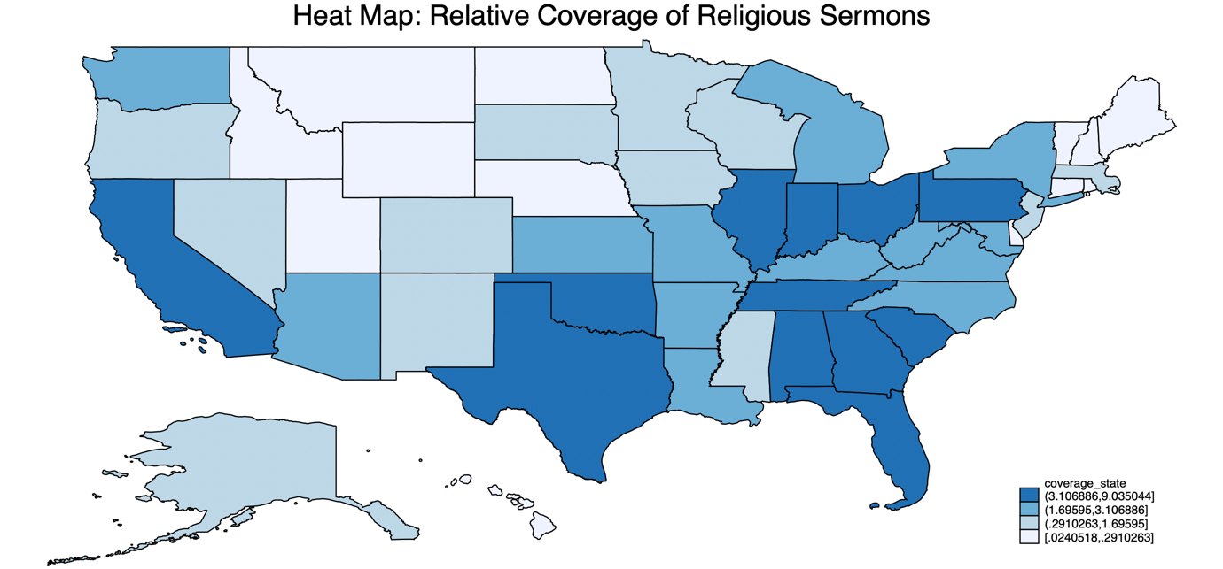

### State: Adjusted Relative Coverage

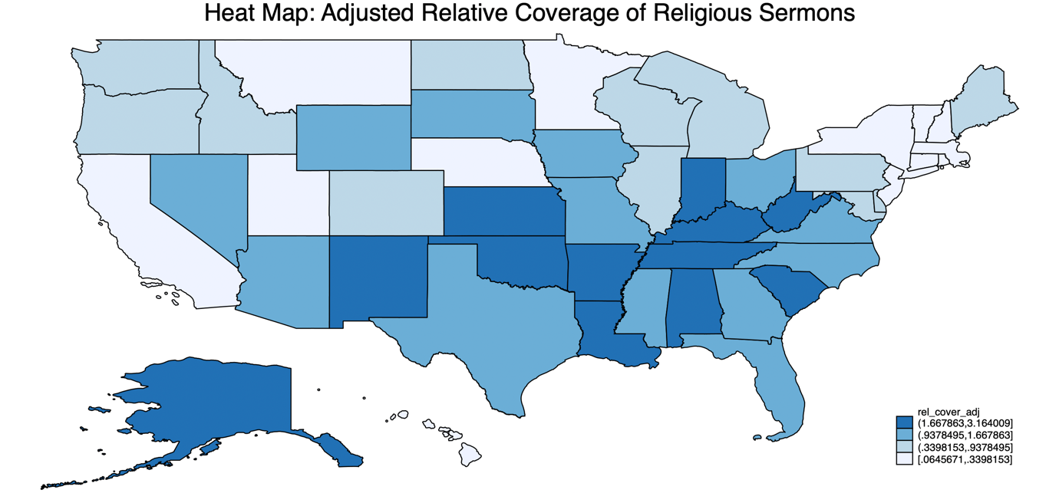

### Election-Related Words

The words screened in religious sermons include: vote, voted, voting, ballot, candidate, nominate, elect, president, politician, politicians, re-vote.

#### RDD Style Graphs

##### Overlapping Graphs for All Election years: 12 months before & after election



##### Overlapping Graphs for All Election years: 4 weeks before & after election

##### 

##### Overlapping Graphs for Non-Election years: 4 weeks before & after the Tuesday between 2nd and 8th November



##### 2004 Election: George Bush and John Kerry



##### 2008 Election: John McCain and Barack Obama



##### 2012 Election: Mitt Romney and Barack Obama



##### 2016 Election: Donald Trump and Hilary Clinton



##### 2020 Election: Donald Trump and Joe Biden



#### Word Count Graph



### Presidential Election Candidates’ Mentions

The words screened include: George W. Bush, John Kerry, George Bush, kerry, george bush, Barack Obama, John McCain, obama, john mccain, John Mccain, President obama, barack, Mitt Romney, mitt romney, romney, Donald Trump, Hillary Clinton, Clinton, hillary, donald, Joe Biden, biden, President Bush, President Obama, President Trump, President Biden

#### RDD style graphs

##### Overlapping Graphs for All Election years: 12 months before & after election



##### Overlapping Graphs for All Election years: 4 weeks before & after an election



##### Overlapping Graphs for Non-Election years: 4 weeks before & after Tuesday between 2nd and 8th November.



##### 2004 Election: George Bush and John Kerry



##### 2008 Election: John McCain and Barack Obama



##### 2012 Election: Mitt Romney and Barack Obama



##### 2016 Election: Donald Trump and Hilary Clinton



##### 2020 Election: Donald Trump and Joe Biden



#### Word Count Graph



### RDD-Style Graphs: Sermon Count and View Count

#### Count of Sermons: 4 weeks before and after the nearest election



#### Count of Sermons: 12 months before and after the nearest election



#### Total Views of Sermons: 4 weeks before and after the nearest election



#### Total Views of Sermons: 12 months before and after the nearest election



## Pastor-Level Controls

|  |  |  |  |  |  |  |  |  |  |
| --- | --- | --- | --- | --- | --- | --- | --- | --- | --- |
| **Variables** | **Obs** | **Mean** | **Std. Dev.** | **Min** | **Max** | **p1** | **p99** | **Skew.** | **Kurt.** |
| married0 | 163056 | 0.487 | 0.5 | 0 | 1 | 0 | 1 | 0.052 | 1.003 |
| married | 83097 | 0.955 | 0.208 | 0 | 1 | 0 | 1 | -4.381 | 20.195 |
| children0 | 140606 | 1.117 | 1.71 | 0 | 9 | 0 | 7 | 1.475 | 4.659 |
| children | 57918 | 2.737 | 1.654 | 0 | 9 | 0 | 8 | 0.562 | 3.858 |
| edu theology0 | 163761 | 0.107 | 0.309 | 0 | 1 | 0 | 1 | 2.541 | 7.455 |
| edu theology | 103345 | 0.167 | 0.373 | 0 | 1 | 0 | 1 | 1.79 | 4.204 |
| edu theological0 | 163761 | 0.283 | 0.451 | 0 | 1 | 0 | 1 | 0.962 | 1.925 |
| edu theological | 103345 | 0.446 | 0.497 | 0 | 1 | 0 | 1 | 0.218 | 1.047 |
| edu0 | 144946 | 1.675 | 1.533 | 0 | 4 | 0 | 4 | 0.069 | 1.41 |
| edu | 84542 | 2.872 | 0.768 | 1 | 4 | 1 | 4 | -0.104 | 2.355 |
| denom index | 164133 | 15.923 | 10.728 | 1 | 39 | 1 | 39 | 0.536 | 1.904 |
| family index | 164133 | 9.547 | 5.178 | 1 | 16 | 3 | 16 | -0.298 | 1.363 |
| exp bin | 8765 | 26.826 | 12.317 | 10 | 60 | 10 | 50 | 0.409 | 2.332 |
|  | | | | | | | | | |

The explanation behind the variables and their construction can be explained below:

### Married0

**Married0** is a binary (dummy) variable that takes the value **1** if the pastor is married and **0** if the pastor is not married.

To construct this variable, the following steps were followed:

**Step 1: Identifying Relevant Text Fields**

To determine a pastor’s marital status, text from the following variables was screened:

* **'family'**
* **'whatmyspousereallythinksofmyserm'**
* **'experience'**

**Step 2: Keyword Matching**

The classification was based on specific keywords found in these text fields:

**Indications of being married** (assigned **1**):

Words searched in sermons: *wife, husband, married, spouse, helpmate, marriage, casado*

**Indications of being unmarried** (assigned **0**):

Words searched in sermons: *widow, widower, girlfriend, I am single*

**Step 3: Handling Missing Data**

Pastors who did **not** respond to *'whatmyspousereallythinksofmyserm'* and *‘family’* were automatically classified as unmarried (coded as **0**).

**Step 4: Manual Review & Adjustments**

Following the automated classification, a manual review was conducted to validate and refine the variable. A random sample of 10 observations from pastors whose marital status remained unclassified (i.e., not coded as 0 or 1) was drawn. These observations were individually examined to assess whether they were correctly left unclassified. Where appropriate, pastors were manually recoded as married (1), unmarried (0), or missing (.). This process involved using the *strpos* string function to identify relevant keywords in the text fields and ensure more accurate classification. After reviewing the initial 10 observations, the process was repeated iteratively 20 times.

**Married**: The 'married' variable is the same as the 'married0' variable except that pastors who do not respond to the '*whatmyspousereallythinksofmyserm*' variable are treated as missing observations instead of being coded as unmarried (coded as '.').

**Step 5: Plotting Married0 and Married against ‘week_to_nearest_election’**





### Children0:

Children0 is a variable for the number of children a pastor has, ranging from 0 to 9.

To construct this variable, the following steps were followed:

**Step 1: Identifying Relevant Text Fields**

To determine the number of children a pastor has, information was extracted from the ‘family’ variable.

**Step 2: Keyword Matching**

The classification was based on specific keywords found in these text fields, by using commonly used phrases to describe number of children to build the variable.

**Indication that a pastor has no kids** (assigned children = 0):

Words searched in sermons:

* *we don’t have children, we don't have any children, i don’t have children, i don't have any children*
* *no kids, no children*
* *just me and my wife, just me and my husband, just my wife and me, just my husband and me, it’s just the two of us, just my wife, just my husband, just my parents*

**Indication that a pastor has one child** (assigned children = 1):

Words searched in sermons:

* *one child, 1 child, one kid, 1 kid*
* *one grown child, 1 grown child, one grown kid, 1 grown kid, one adult child, 1 adult child, one adult kid, 1 adult kid, one married child, 1 married child, one married kid, 1 married kid, one beautiful child, 1 beautiful child, one beautiful kid, 1 beautiful kid, one wonderful child, 1 wonderful child, one wonderful kid, 1 wonderful kid, one great child, 1 great child, one great kid, 1 great kid, one terrific kid, 1 terrific kid*
* *one son, 1 son, one boy, 1 boy, one daughter, 1 daughter, one girl, 1 girl, our only child, first and only child, our one child, our 1 child*
* *one adult son, 1 adult son, one adult daughter, 1 adult daughter, one married son, 1 married son, one married daughter, 1 married daughter, one grown son, 1 grown son, one grown daughter, 1 grown daughter, one beautiful son, 1 beautiful son, one beautiful daughter, 1 beautiful daughter, one wonderful son, 1 wonderful son, one wonderful daughter, 1 wonderful daughter, one amazing son, 1 amazing son, one amazing daughter, 1 amazing daughter, one great son, 1 great son, one great daughter, 1 great daughter, one terrific son, 1 terrific son, one terrific daughter, 1 terrific daughter*
* *1 stepson, one stepson, 1 stepdaughter, one stepdaughter*

**Indication that a pastor has two children** (assigned children = 2):

Words searched in sermons:

* *two children, 2 children, two kids, 2 kids*
* *two grown children, 2 grown children, , two grown kids, 2 grown kids, two adult children, 2 adult children, two adult kids, 2 adult kids, two married children, 2 married children, two married kids, 2 married kids, two beautiful children, 2 beautiful children, two beautiful kids, 2 beautiful kids, two wonderful children, 2 wonderful children, two wonderful kids, 2 wonderful kids, two amazing children, 2 amazing children, two amazing kids, 2 amazing kids, two great children, 2 great children, two great kids, 2 great kids, two terrific children, 2 terrific children, two terrific kids, 2 terrific kids*
* *two sons, 2 sons, two boys, 2 boys, two daughters, 2 daughters, two girls, 2 girls, one son and one daughter, a son and a daughter, 1 son and 1 daughter, one daughter and one son, a daughter and a son, 1 daughter and 1 son*
* *two adult sons, 2 adult sons, two adult daughters, 2 adult daughters, two married sons, 2 married sons, two married daughters, 2 married daughters, two grown-up sons, 2 grown-up sons, two grown-up daughters, 2 grown-up daughters, two beautiful sons, 2 beautiful sons, two beautiful daughters, 2 beautiful daughters, two wonderful sons, 2 wonderful sons, two wonderful daughters, 2 wonderful daughters, two amazing sons, 2 amazing sons, two amazing daughters, 2 amazing daughters, two great sons, 2 great sons, two great daughters, 2 great daughters, two terrific sons, 2 terrific sons, two terrific daughters, 2 terrific daughters*
* *two stepchildren, 2 stepchildren*

**Indication that a pastor has three children** (assigned children = 3):

Words searched in sermons:

* *three children, 3 children, three kids, 3 kids*
* *three grown children, 3 grown children, , three grown kids, 3 grown kids, three adult children, 3 adult children, three adult kids, 3 adult kids, three married children, 3 married children, three married kids, 3 married kids, three beautiful children, 3 beautiful children, three beautiful kids, 3 beautiful kids, three wonderful children, 3 wonderful children, three wonderful kids, 3 wonderful kids, three amazing children, 3 amazing children, three amazing kids, 3 amazing kids, three great children, 3 great children, three great kids, 3 great kids, three terrific children, 3 terrific children, three terrific kids, 3 terrific kids*
* *three sons, 3 sons, three boys, 3 boys, three daughters, 3 daughters, three girls, 3 girls, one son and two daughters, 1 son and 2 daughters, a son and two daughters, a son and 2 daughters, two sons and one daughter, 2 sons and 1 daughter, two sons and a daughter, 2 sons and a daughter, one daughter and two sons, 1 daughter and 2 sons, a daughter and two sons, a daughter and 2 sons, two daughters and one son, 2 daughters and 1 son, two daughters and a son, 2 daughters and a son*
* *three adult sons, 3 adult sons, three adult daughters, 3 adult daughters, three married sons, 3 married sons, three married daughters, 3 married daughters, three grown-up sons, 3 grown-up sons, three grown-up daughters, 3 grown-up daughters, three beautiful sons, 3 beautiful sons, three beautiful daughters, 3 beautiful daughters, three wonderful sons, 3 wonderful sons, three wonderful daughters, 3 wonderful daughters, three amazing sons, 3 amazing sons, three amazing daughters, 3 amazing daughters, three great sons, 3 great sons, three great daughters, 3 great daughters, three terrific sons, 3 terrific sons, three terrific daughters, 3 terrific daughters*
* *three stepchildren, 3 stepchildren*

**Indication that a pastor has four children** (assigned children = 4):

Words searched in sermons:

* *four children, 4 children, four kids, 4 kids*
* *four grown children, 4 grown children, , four grown kids, 4 grown kids, four adult children, 4 adult children, four adult kids, 4 adult kids, four married children, 4 married children, four married kids, 4 married kids, four beautiful children, 4 beautiful children, four beautiful kids, 4 beautiful kids, four wonderful children, 4 wonderful children, four wonderful kids, 4 wonderful kids, four amazing children, 4 amazing children, four amazing kids, 4 amazing kids, four great children, 4 great children, four great kids, 4 great kids, four terrific children, 4 terrific children, four terrific kids, 4 terrific kids*
* *four sons, 4 sons, four boys, 4 boys, four daughters, 4 daughters, four girls, 4 girls, one son and three daughters, 1 son and 3 daughters, a son and three daughters, a son and 3 daughters, two sons and two daughters, 2 sons and 2 daughters, three sons and one daughter, 3 sons and 1 daughter, three sons and a daughter, 3 sons and a daughter, one daughter and three sons, 1 daughter and 3 sons, a daughter and three sons, a daughter and 3 sons, three daughters and one son, 3 daughters and 1 son, three daughters and one son, three daughters and a son, 3 daughters and a son*
* *four adult sons, 4 adult sons, four adult daughters, 4 adult daughters, four married sons, 4 married sons, four married daughters, 4 married daughters, four grown-up sons, 4 grown-up sons, four grown-up daughters, 4 grown-up daughters, four beautiful sons, 4 beautiful sons, four beautiful daughters, 4 beautiful daughters, four wonderful sons, 4 wonderful sons, four wonderful daughters, 4 wonderful daughters, four amazing sons, 4 amazing sons, four amazing daughters, 4 amazing daughters, four great sons, 4 great sons, four great daughters, 4 great daughters, four terrific sons, 4 terrific sons, four terrific daughters, 4 terrific daughters*
* *four stepchildren, 4 stepchildren*

**Indication that a pastor has five children** (assigned children = 5):

Words searched in sermons:

* *five children, 5 children, five kids, 5 kids*
* *five grown children, 5 grown children, , five grown kids, 5 grown kids, five adult children, 5 adult children, five adult kids, 5 adult kids, five married children, 5 married children, five married kids, 5 married kids, five beautiful children, 5 beautiful children, five beautiful kids, 5 beautiful kids, five wonderful children, 5 wonderful children, five wonderful kids, 5 wonderful kids, five amazing children, 5 amazing children, five amazing kids, 5 amazing kids, five great children, 5 great children, five great kids, 5 great kids, five terrific children, 5 terrific children, five terrific kids, 5 terrific kids*
* *five sons, 5 sons, five boys, 5 boys, five daughters, 5 daughters, five girls, 5 girls*
* *one son and four daughters, 1 son and 4 daughters, a son and four daughters, a son and 4 daughters, two sons and three daughters, 2 sons and 3 daughters, three sons and two daughters, 3 sons and 2 daughters, four sons and one daughter, 4 sons and 1 daughter, one daughter and four sons, 1 daughter and 4 sons, a daughter and four sons, a daughter and 4 sons, two daughters and three sons, 2 daughters and 3 sons, three daughters and two sons, 3 daughters and 2 sons, four daughters and one son, 4 daughters and 1 son, four daughters and a son, 4 daughters and a son*
* *five adult sons, 5 adult sons, five adult daughters, 5 adult daughters, five married sons, 5 married sons, five married daughters, 5 married daughters, five grown-up sons, 5 grown-up sons, five grown-up daughters, 5 grown-up daughters, five beautiful sons, 5 beautiful sons, five beautiful daughters, 5 beautiful daughters, five wonderful sons, 5 wonderful sons, five wonderful daughters, 5 wonderful daughters, five amazing sons, 5 amazing sons, five amazing daughters, 5 amazing daughters, five great sons, 5 great sons, five great daughters, 5 great daughters, five terrific sons, 5 terrific sons, five terrific daughters, 5 terrific daughters*
* *five stepchildren, 5 stepchildren*

**Indication that a pastor has six children** (assigned children = 6):

Words searched in sermons:

* *six children, 6 children, six kids, 6 kids*
* *six grown children, 6 grown children, , six grown kids, 6 grown kids, six adult children, 6 adult children, six adult kids, 6 adult kids, six married children, 6 married children, six married kids, 6 married kids, six beautiful children, 6 beautiful children, six beautiful kids, 6 beautiful kids, six wonderful children, 6 wonderful children, six wonderful kids, 6 wonderful kids, six amazing children, 6 amazing children, six amazing kids, 6 amazing kids, six great children, 6 great children, six great kids, 6 great kids, six terrific children, 6 terrific children, six terrific kids, 6 terrific kids*
* *six sons, 6 sons, six boys, 6 boys, six daughters, 6 daughters, six girls, 6 girls,*
* *one son and five daughters, 1 son and 5 daughters, a son and five daughters, a son and 5 daughters, two sons and four daughters, 2 sons and 4 daughters, three sons and three daughters, 3 sons and 3 daughters, four sons and two daughters, 4 sons and 2 daughters, five sons and one daughter, 5 sons and 1 daughter, 5 sons and a daughter, five sons and a daughter, one daughter and five sons, 1 daughter and 5 sons, a daughter and five sons, a daughter and 5 sons, two daughters and four sons, 2 daughters and 4 sons, three daughters and three sons, 3 daughters and 3 sons, four daughters and two sons, 4 daughters and 2 sons, 5 daughters and 1 son, five daughters and one son, five daughters and a son, 5 daughters and a son*
* *six adult sons, 6 adult sons, six adult daughters, 6 adult daughters, six married sons, 6 married sons, six married daughters, 6 married daughters, six grown-up sons, 6 grown-up sons, six grown-up daughters, 6 grown-up daughters, six beautiful sons, 6 beautiful sons, six beautiful daughters, 6 beautiful daughters, six wonderful sons, 6 wonderful sons, six wonderful daughters, 6 wonderful daughters, six amazing sons, 6 amazing sons, six amazing daughters, 6 amazing daughters, six great sons, 6 great sons, six great daughters, 6 great daughters, six terrific sons, 6 terrific sons, six terrific daughters, 6 terrific daughters*
* *six step-children, 6 stepchildren*

**Indication that a pastor has seven children** (assigned children = 7):

Words searched in sermons:

* *seven children, 7 children, seven kids, 7 kids*
* *seven grown children, 7 grown children, , seven grown kids, 7 grown kids, seven adult children, 7 adult children, seven married children, 7 married children, seven married kids, 7 married kids, seven adult kids, 7 adult kids, seven beautiful children, 7 beautiful children, seven wonderful children, 7 wonderful children, seven amazing kids, 7 amazing kids, seven great kids, 7 great kids, seven terrific kids, 7 terrific kids,*
* *seven sons, 7 sons, seven boys, 7 boys, seven daughters, 7 daughters, seven girls, 7 girls*
* *one son and six daughters, 1 son and 6 daughters, a son and six daughters, a son and 6 daughters, two sons and five daughters, 2 sons and 5 daughters, three sons and four daughters, 3 sons and 4 daughters, four sons and three daughters, 4 sons and 3 daughters, five sons and two daughters, 5 sons and 2 daughters, six sons and one daughter, 6 sons and 1 daughter, six sons and a daughter, 6 sons and a daughter, one daughter and six sons, 1 daughter and 6 sons, a daughter and six sons, a daughter and 6 sons, two daughters and five sons, 2 daughters and 5 sons, three daughters and four sons, 3 daughters and 4 sons, four daughters and three sons, 4 daughters and 3 sons, five daughters and two sons, 5 daughters and 2 sons, six daughters and one son, 6 daughters and 1 son, 6 daughters and a son, six daughters and a son*
* *seven adult sons, 7 adult sons, seven adult daughters, 7 adult daughters, seven married sons, 7 married sons, seven married daughters, 7 married daughters, seven grown-up sons, 7 grown-up sons, seven grown-up daughters, 7 grown-up daughters, seven beautiful sons, 7 beautiful sons, seven beautiful daughters, 7 beautiful daughters, seven wonderful sons, 7 wonderful sons, seven wonderful daughters, 7 wonderful daughters, seven amazing sons, 7 amazing sons, seven amazing daughters, 7 amazing daughters, seven great sons, 7 great sons, seven great daughters, 7 great daughters, seven terrific sons, 7 terrific sons, seven terrific daughters, 7 terrific daughters*
* *seven step-children, 7 step-children*

**Indication that a pastor has eight children** (assigned children = 8):

Words searched in sermons:

* *eight children, 8 children, eight kids, 8 kids*
* *eight grown children, 8 grown children, , eight grown kids, 8 grown kids, eight adult children, 8 adult children, eight adult kids, 8 adult kids, eight married children, 8 married children, eight married kids, 8 married kids, eight beautiful children, 8 beautiful children, eight beautiful kids, 8 beautiful kids, eight wonderful children, 8 wonderful children, eight wonderful kids, 8 wonderful kids, eight amazing children, 8 amazing children, eight amazing kids, 8 amazing kids, eight great children, 8 great children, eight great kids, 8 great kids, eight terrific children, 8 terrific children, eight terrific kids, 8 terrific kids*
* *eight sons, 8 sons, eight boys, 8 boys, eight daughters, 8 daughters, eight girls, 8 girls,*
* *one son and seven daughters, 1 son and 7 daughters, a son and seven daughters, a son and 7 daughters, two sons and six daughters, 2 sons and 6 daughters, three sons and five daughters, 3 sons and 5 daughters, four sons and four daughters, 4 sons and 4 daughters, five sons and three daughters, 5 sons and 3 daughters, six sons and two daughters, 6 sons and 2 daughters, seven sons and one daughter, 7 sons and 1 daughter, 7 sons and a daughter, seven sons and a daughter, one daughter and seven sons, 1 daughter and 7 sons, a daughter and seven sons, a daughter and 7 sons, , two daughters and six sons, 2 daughters and 6 sons, three daughters and five sons, 3 daughters and 5 sons, four daughters and four sons, 4 daughters and 4 sons, five daughters and three sons, 5 daughters and 3 sons, six daughters and two sons, 6 daughters and 2 sons, seven daughters and one son, 7 daughters and 1 son, 7 daughters and a son, seven daughters and a son*
* *eight adult sons, 8 adult sons, eight adult daughters, 8 adult daughters, eight married sons, 8 married sons, eight married daughters, 8 married daughters, eight grown-up sons, 8 grown-up sons, eight grown-up daughters, 8 grown-up daughters, eight beautiful sons, 8 beautiful sons, eight beautiful daughters, 8 beautiful daughters, eight wonderful sons, 8 wonderful sons, eight wonderful daughters, 8 wonderful daughters, eight amazing sons, 8 amazing sons, eight amazing daughters, 8 amazing daughters, eight great sons, 8 great sons, eight great daughters, 8 great daughters, eight terrific sons, 8 terrific sons, eight terrific daughters, 8 terrific daughters*
* *eight step-children, 8 step-children*

**Indication that a pastor has nine children** (assigned children = 9):

Words searched in sermons:

* *nine children, 9 children, nine kids, 9 kids*
* *nine grown children, 9 grown children, , nine grown kids, 9 grown kids, nine adult children, 9 adult children, nine adult kids, 9 adult kids, nine married children, 9 married children, nine married kids, 9 married kids, nine beautiful children, 9 beau-tiful children, nine beautiful kids, 9 beautiful kids, nine wonderful children, 9 won-derful children, nine wonderful kids, 9 wonderful kids, nine amazing children, 9 amazing children, nine amazing kids, 9 amazing kids, nine great children, 9 great children, nine great kids, 9 great kids, nine terrific children, 9 terrific children, nine terrific kids, 9 terrific kids*
* *nine sons, 9 sons, nine boys, 9 boys, nine daughters, 9 daughters, nine girls, 9 girls*
* *one son and eight daughters, 1 son and 8 daughters, a son and eight daughters, a son and 8 daughters, two sons and seven daughters, 2 sons and 7 daughters, three sons and six daughters, 3 sons and 6 daughters, four sons and five daughters, 4 sons and 5 daughters, five sons and four daughters, 5 sons and 4 daughters, six sons and three daughters, 6 sons and 3 daughters, seven sons and two daughters, 7 sons and 2 daughters, eight sons and one daughter, 8 sons and 1 daughter, eight sons and a daughter, 8 sons and a daughter, one daughter and eight sons, 1 daughter and 8 sons, a daughter and eight sons, a daughter and 8 sons, two daughters and seven sons, 2 daughters and 7 sons, three daughters and six sons, 3 daughters and 6 sons, four daughters and five sons, 4 daughters and 5 sons, five daughters and four sons, 5 daughters and 4 sons, six daughters and three sons, 6 daughters and 3 sons, seven daughters and two sons, 7 daughters and 2 sons, eight daughters and one son, 8 daughters and one son, eight daughters and a son, 8 daughters and a son.*
* *nine adult sons, 9 adult sons, nine adult daughters, 9 adult daughters, nine married sons, 9 married sons, nine married daughters, 9 married daughters, nine grown-up sons, 9 grown-up sons, nine grown-up daughters, 9 grown-up daughters, nine beautiful sons, 9 beautiful sons, nine beautiful daughters, 9 beautiful daughters, nine wonderful sons, 9 wonderful sons, nine wonderful daughters, 9 wonderful daughters, nine amazing sons, 9 amazing sons, nine amazing daughters, 9 amazing daughters, nine great sons, 9 great sons, nine great daughters, 9 great daughters, nine terrific sons, 9 terrific sons, nine terrific daughters, 9 terrific daughters*
* *nine step-children, 9 step-children*

**Step 3: Handling Missing Data**

To ensure accuracy, pastors who did **not** respond to *'family'* were automatically classified as having no children (coded as **0**).

**Children**: The 'children' variable is the same as the 'children0' variable except that pastors who do not respond to the '*family*' variable are treated as missing observations instead of being coded as not having a family (coded as '.').

**Step 4: Plotting Children0 and Children against ‘week_to_nearest_election’**





### Edu theology0:

Edu theology0 is a binary (dummy) variable that takes the value **1** if the pastor has a degree in theology, and 0 if the pastor has does not have a degree in theology.

To construct this variable, the following steps were followed:

**Step 1: Identifying Relevant Text Fields**

To determine whether a pastor pursued a degree in theology, information was extracted from the ‘education’ variable.

**Step 2: Keyword Matching**

The classification was based on specific keywords found in the text field of ‘education’

**Indications of having a degree in theology** (assigned **1**):

Words searched in sermons: *Theology, Th.M, ThD, Master of Theology, MTh, BTh, Th.D*

**Indications of not having a degree in theology** (assigned **0**):

All other observations which did not contain the words indicative of a theological degree were coded as 0. This included pastors who studied non-theology courses at theological institute at university.

**Step 3: Handling Missing Data**

To ensure accuracy, pastors who did **not** respond to *'education'* were automatically classified as having no degree in theology (coded as **0**).

**Edu theology**: The 'edu theology' variable is the same as the 'edu theology0' variable except that pastors who do not respond to the '*education*' variable are treated as missing observations instead of being coded as not having a degree in theology(coded as '.').

**Step 4: Plotting Edu_theology0 and Edu_theology against ‘week_to_nearest_election’**





### Edu theological0:

Edu theological0 is a binary (dummy) variable that takes the value 1 if the pastor studied at a theological institution or department, or 0 otherwise.

**Note:** The variable Edu theological also includes the pastors which pursued a degree in theology (from the variable edu theology)

To construct this variable, the following steps were followed:

**Step 1: Identifying Relevant Text Fields**

To determine whether a pastor pursued a degree from a theological institute, information was extracted from the ‘education’ variable.

**Step 2: Keyword Matching**

The classification was based on specific keywords found in the text field of ‘education’

**Indications of having a degree at a theological institute** (assigned **1**):

Words searched in sermons: *Theology, Th.M, ThD, Master of Theology, MTh, BTh, Th.D, theological*

**Indications of not having a degree at a theological institute** (assigned **0**):

All other observations which did not contain the words indicative of a degree at a theological institute were coded as 0.

**Step 3: Handling Missing Data**

To ensure accuracy, pastors who did **not** respond to *'education'* were automatically classified as having no degree at a theological institute (coded as **0**).

**Edu theological**: The 'Edu theological' variable is the same as the 'Edu theological0' variable except that pastors who do not respond to the '*education*' variable are treated as missing observations instead of being coded as not having a degree from a theological institute (coded as '.').

**Step 4: Plotting Edu_theological0 and Edu_theological against ‘week_to_nearest_election’**



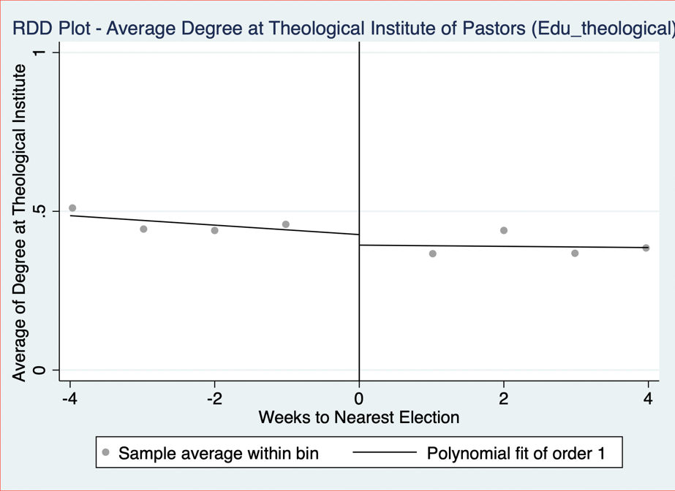

### Edu0:

Edu0 is a categorical variable for the level of education a pastor has, where:

* 1 = high school degree
* 2 = bachelor’s degree
* 3 = master’s degree
* 4 = PhD

To construct this variable, the following steps were followed:

**Step 1: Identifying Relevant Text Fields**

To determine a pastor’s level of education, information was extracted from the ‘education’ variable.

**Step 2: Keyword Matching**

The classification was based on specific keywords found in the ‘education; text field, by using commonly used phrases to describe education level to build the variable.

**Indication that a pastor has a high-school diploma (coded as 1):**

Words searched in sermons: *High School, HS diploma, school degree, Eagle Academy, Associate of Arts*

**Indication that a pastor has a bachelor’s degree (coded as 2):**

Words searched in sermons: *Bachelor, Bachelors, BA, BSC, undergraduate, B.A., Bachelor of Art, BS, B.S., BTh, Business Degree,*

**Indication that a pastor has a master’s degree (coded as 3):**

Words searched in sermons: *Masters*, *Th.M, Master of Theology, MTh, M.Div, Master, MA, MDiv, MOM.Div., M A, MAOM*

**Indication that a pastor has a PhD (coded as 4):**

Words searched in sermons: *PhD, Doctorate, Doctor of, Th.D, ThD*

**Note:** Pastors with Associate of Arts degrees were classified as having a high school diploma, even though an AA degree is higher than a high school diploma but lower than a bachelor's degree. This classification was made due to its equivalence to the first or second year of a bachelor's program.

**Step 3: Handling Missing Data**

To ensure accuracy, pastors who did **not** respond to *'education'* were automatically classified as having no education (coded as **0**).

**Step 4: Manual Review & Adjustments**

Following the automated classification, a manual review was conducted to validate and refine the education variable. A random sample of 10 observations from pastors whose education level remained unclassified (i.e., not yet coded) was drawn. These cases were individually examined to assess whether they were correctly left unclassified. Where appropriate, pastors were manually recoded based on the highest level of education identified. This process involved using the strpos string function to detect relevant educational keywords in the text fields, ensuring more consistent and accurate classification. After reviewing the initial 10 observations, the process was repeated iteratively 20 times.

**Edu**: The 'edu' variable is the same as the 'edu0' variable except that pastors who do not respond to the '*education*' variable are treated as missing observations instead of being coded as not having an education (coded as '.').

**Step 5: Plotting Edu0 and Edu against ‘week_to_nearest_election’**





### Denom_index:

Denom_Index is a numerical variable representing the religious denomination of the pastor. It assigns a numerical index to each denomination, as listed in Section 1.3.

**Denominations with High Relative Coverage**

To take a closer look at the denomination of Pastors, separate dummy variables were created for the ‘Baptist’, ‘Evangelical/Non-Denominational’, and ‘Christian/Church of Christ’ denominations. All other denominations were grouped together under a binary variable labeled ‘OtherDenom’. Descriptive statistics for these variables are presented below.

|  |  |  |  |  |  |  |  |  |  |
| --- | --- | --- | --- | --- | --- | --- | --- | --- | --- |
| **Variables** | **Obs** | **Mean** | **Std. Dev.** | **Min** | **Max** | **p1** | **p99** | **Skew.** | **Kurt.** |
| Baptist | 164133 | 0.333 | 0.471 | 0 | 1 | 0 | 1 | 0.707 | 1.499 |
| Evangelical | 164133 | 0.115 | 0.319 | 0 | 1 | 0 | 1 | 2.418 | 6.848 |
| ChurchofChrist | 164133 | 0.105 | 0.307 | 0 | 1 | 0 | 1 | 2.571 | 7.612 |
| OtherDenom | 164133 | 0.447 | 0.497 | 0 | 1 | 0 | 1 | 0.215 | 1.046 |
|  | | | | | | | | | |

**Checking for Smoothness in High-Relative-Coverage Denominations:**

The RDD-style graphs for Baptist, Evangelical/Non-Denominational, and Christian/Church of Christ pastors, as well as pastors from all other denominations, are presented below.

 

 

### Family_index:

Family_index is a numerical variable representing the religious family of the pastor. It assigns a numerical index to each religious family, as listed in Section ‎1.4. To clarify the distinction between denomination and religious family: denominations were self-reported by pastors and provide a more detailed, granular classification. Religious families, on the other hand, group these denominations into broader categories based on ARDA’s classifications.

**Religious Families with High Relative and High Adjusted Relative Coverage**

To take a closer look at the religious families of Pastors, separate dummy variables were created for the ‘Baptist’ and ‘Pentecostal’ families which had a high relative coverage and for the ‘Froehlich’ Family which had a High Adjusted Relative Coverage. All other religious families were grouped together under a binary variable labeled ‘OtherFam’. Descriptive statistics for these variables are presented below.

|  |  |  |  |  |  |  |  |  |  |
| --- | --- | --- | --- | --- | --- | --- | --- | --- | --- |
| **Variables** | **Obs** | **Mean** | **Std. Dev.** | **Min** | **Max** | **p1** | **p99** | **Skew.** | **Kurt.** |
| Baptist Family | 164133 | .333 | .471 | 0 | 1 | 0 | 1 | .707 | 1.499 |
| Pentecostal Family | 164133 | .155 | .361 | 0 | 1 | 0 | 1 | 1.912 | 4.654 |
| Froehlich Family | 164133 | .018 | .132 | 0 | 1 | 0 | 1 | 7.328 | 54.694 |
| OtherFam | 164133 | .494 | .5 | 0 | 1 | 0 | 1 | .022 | 1 |
|  | | | | | | | | | |

**Checking for Smoothness in High (Adjusted) Relative Coverage Religious Families:**

The RDD-style graphs for pastors from Baptist, Pentecostal, and Froehlich religious families, as well as pastors from all other religious families, are presented below.

 

 

### Exp bin:

Exp bin is a categorical variable for the level of experience of the pastor has, binned into the following categories:

* 10: from 0-10 years of experience
* 20: from 11-20 years of experience
* 30: from 21-30 years of experience
* 40: from 31-40 years of experience
* 50: from 41-50 years of experience
* 60: 51+ years of experience

To construct this variable, the following steps were followed:

**Step 1: Identifying Relevant Text Fields**

To determine a pastor’s level of experience, information was extracted from the ‘experience’ variable.

**Step 2: Manual Review**

Since the responses in the experience variable were highly heterogeneous, approximately 19,000 observations of the experience variable were manually coded. This process involved either:

* Directly extracting the number of years of experience provided by the pastor, or
* Applying the following method:
  + Extracting any dates mentioned by the pastor.
  + Comparing these dates to the sermon contribution date to calculate the total years of experience.
  + Assigning the corresponding experience bin based on the calculated number of years.

**Step 3: Using ChatGPT API to classify Exp Bin:**

To classify the exp_bin variable for all observations, the ChatGPT API was used to categorize all the sermons based on 400 manually coded observations. The process followed these steps:

1. Reference Set Creation:
   1. A sample of 400 manually coded observations was extracted to serve as reference examples.
   2. These examples demonstrated how pastors’ descriptions were mapped to experience bins.
2. Prompt Design:
   1. The system prompt included:
   2. The reference examples for pattern recognition.
   3. Rules for assigning experience bins based on mentioned years or inferred tenure. If pastors mention retirement from the military, GPT was instructed to add 20 years on top of their years of experience.
   4. If experience was missing or unclear, GPT was instructed to return a placeholder (".") rather than forcing a classification.
3. Processing with GPT:
   1. For each pastor, a structured input was created with:
      1. The unique id of the pastor
      2. Their experience field.
      3. Their latest sermon contribution date (to infer years of experience).
   2. The GPT model was queried with this information.
   3. The returned classifications were saved and merged with the main dataset.

**Step 4: Plotting Exp_Bin against ‘week_to_nearest_election’**



**Note of Discretion regarding Experience Coding:**

The classification of pastoral experience is based on self-reported information, which introduces several limitations. Some pastors reported overlapping church and non-church roles separately (e.g., serving part-time as a pastor while working another job), which may inflate their total years of pastoral service. In contrast, others focused solely on church-related roles and omitted relevant non-church experience, making comparisons across individuals more difficult. For retired military veterans, 20 years were added to their church-related experience to account for military service; however, actual lengths of service may differ from this standardized adjustment.

## Sentiment Analysis

Two sentiment models were used to analyse sermon text sentences mentioning presidential candidates. The sentences before and after were considered when classifying each mention to give more context to the sentiment of the statement – we refer to such a collection of sentences as a sentence block. The analysis was run on two datasets: one that contained sentence blocks that mention at least one candidate, and another that contained only sentence blocks that mention exactly one candidate. For sentence blocks that mention exactly one candidate, the analysis for Bill Clinton and Hillary Clinton captures only sentence blocks that contain “Bill Clinton” and “Hillary Clinton”, respectively, without discarding if the other is also mentioned. The analysis for Clinton captures sentence blocks that contain any of “Bill Clinton”, “Hillary Clinton”, or “Clinton” and can be thought of as the Clinton family. 240 of the 337 captured sentence blocks mention exactly one candidate.

### Positive/Negative Sentiment Analysis:

The first model, distilbert-base-uncased-finetuned-sst-2-english, classified sentiment as positive or negative. The candidates were then ranked by their difference in percent of mentions labelled positive and percent of mentions labelled negative. The following outputs were produced.

#### At Least 1 Candidate Mentioned in Sentence Block:

Candidate Sentiment Ranking

|  |  |  |  |  |  |  |
| --- | --- | --- | --- | --- | --- | --- |
| Rank | Name | Party | Total Mentions | Pos % | Neg % | Pos - Neg % |
| 1 | Kerry | Democrat | 19 | 57.89 | 42.11 | 15.78 |
| 2 | Trump | Republican | 118 | 51.69 | 48.31 | 3.38 |
| 3 | Obama | Democrat | 124 | 45.16 | 54.84 | -9.68 |
| 4 | McCain | Republican | 36 | 44.44 | 55.56 | -11.12 |
| 5 | Bush | Republican | 51 | 43.14 | 56.86 | -13.72 |
| 6 | Clinton | Democrat | 60 | 36.67 | 63.33 | -26.66 |
| 7 | Bill Clinton | Democrat | 23 | 34.78 | 65.22 | -30.44 |
| 8 | Biden | Democrat | 22 | 27.27 | 72.73 | -45.46 |
| 9 | Hillary Clinton | Democrat | 10 | 20.00 | 80.00 | -60.00 |
| 10 | Romney | Republican | 13 | 15.38 | 84.62 | -69.24 |

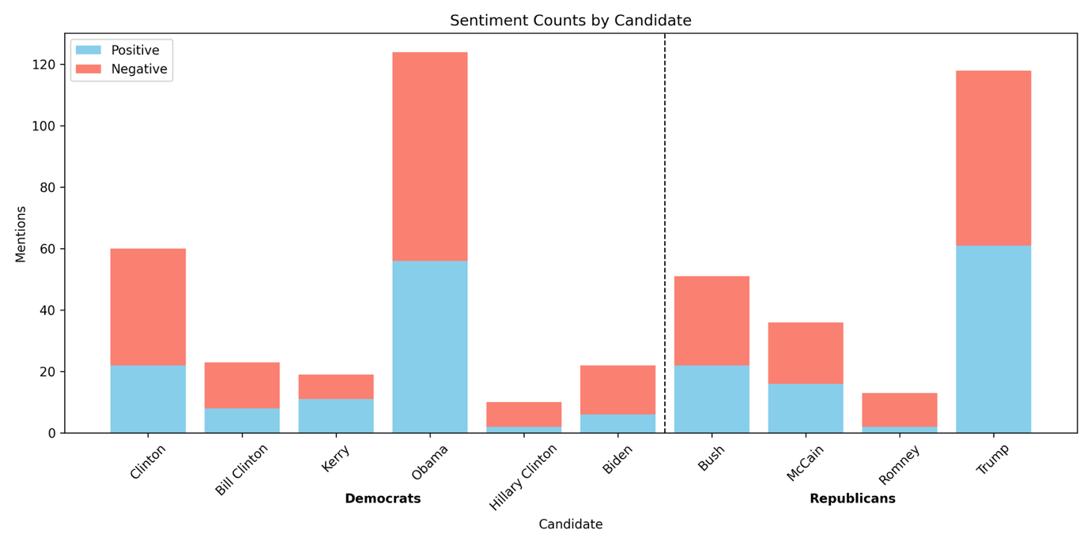

Top Sentence Blocks per Candidate

|  |  |  |
| --- | --- | --- |
| Label | Candidate | Sentence Block |
| Negative | Biden | We must rely on the grace of Christ to carry us through, and His sacramental presence and consolation. What if it gets worse as Biden and Harris have promised it would and lasts for four years or eight or the rest of our lives, God forbid. The Ephesus church also had a third attaboy from St. |
| Negative | Bush | It's the Economy, Stupid. This buzz phrase become very popular during the first President Bush's administration, and could easily be used today. Today let's take a look at God's spiritual economic plan for His people. |
| Negative | Clinton | When reporters hounded him about Clintonian lies, Stephanopoulos accused them of an excess of literalism. Stephanopoulos, to his credit, did tire of the Clinton lies and left the White House. CHALLENGE:Finding the truth, and acting on it, is an old problem. |
| Negative | Bill Clinton | You're sitting there thinking You just told us that you have no idea what a perfect gift is... and now you are going to preach about what one is. That seems like listening to Mickey Rooney pontificate about the dangers of being tall or Roseanne speaking on morality Michael Jordan giving a seminar on How To Survive on A Limited Income, Bill Clinton on Honesty... or Frank Gifford on Marital Fidelity. Now, before you get testy and negative I want you to know I am not speaking from personal experience of from my own wisdom. |
| Negative | Hillary Clinton | 83 a year after taxes. Those opposed to Hillary Clinton will point out that as a First Lady, Senator, and Secretary of State she never accomplished anything. Many accuse her of having an open marriage, allowing her husband the freedom to have affairs. |
| Negative | Kerry | You'll be congratulated for all your hard work, and you'll probably be given a job in the government somewhere that's your reward, if you want it, for working on the campaign for the winner. But if you were on John Kerry's campaign staff, then election day for you is not a good day. All your work didn't result in what you had hoped. |
| Negative | McCain | You might think it would be a disaster. If your perspective is that John McCain is the right man to be our next president, then you might think that an Obama presidency is something to fear. If you have any money invested in the stock market, you've no doubt lost a lot of money in the past few months at least on paper. |
| Negative | Obama | This bad form, bad manners. It would be a little like Obama sending a White House page boy to greet Putin or the Queen of England. 5. |
| Negative | Romney | Conan O'Brien4. Today Mitt Romney visited a firehouse here in New York City. Of course, he was disappointed when he learned that the firehouse is not where you get to fire people. |
| Negative | Trump | Our nation will be in a mess. Those who oppose Trump declare that Islamic Mosques will be closed, inhibiting their freedom of religion. The press will be suppressed with only those in his favor getting access to him. |
| Positive | Biden | WILL WE TRUST HIM. BIDEN. TRUMP. |
| Positive | Bush | B. Following this bold tradition President Bush made the following proclamation concerning thanksgiving on November 21, 2008:Thanksgiving is a time for families and friends to gather together and express gratitude for all that we have been given, the freedoms we enjoy, and the loved ones who enrich our lives. We recognize that all of these blessings, and life itself, come not from the hand of man but from Almighty God. |
| Positive | Clinton | A good teacher inspires a thirst for learning that lasts a lifetime. Bill Clinton said that on August 5, 1993 during a ceremony honoring inductees into the teacher's Hall of Fame. Henry Brooks Adams said, Teachers affect eternity, they can never know the full range of their influence. |
| Positive | Bill Clinton | A good teacher inspires a thirst for learning that lasts a lifetime. Bill Clinton said that on August 5, 1993 during a ceremony honoring inductees into the teacher's Hall of Fame. Henry Brooks Adams said, Teachers affect eternity, they can never know the full range of their influence. |
| Positive | Hillary Clinton | I like to play golf. Hillary Clinton has been dealing with scandals concerning her husband for years. Bill Clinton has been publicly accused by several women of sexual misconduct. |
| Positive | Kerry | One of the candidates answered with a very strong religious statement. It wasn't George Bush because he answered, I don't know -It was Senator John Kerry who said - We're all God's children, he said. And I think if you were to talk to Dick Cheney's daughter, who is a lesbian, she would tell you that she's being who she was. |
| Positive | McCain | John McCain, you are a minister of God. Barack Obama, you are a minister of God. We must look for people to put into office who are moving closer to divine revelation from God. |
| Positive | Obama | And I do my very best to remember Him through His Son, Jesus Christ, and to focus on Him first and foremost in my life. Let us thank all of our veterans for their courageous service for America, and let us also remember to pray for our leaders, including President-elect Barrack Obama and his staff, that they might find themselves being led by God Almighty in their administration of this blessed nation. This is a time of healing and refocusing on our Lord, not a time of bitterness and negativity. |
| Positive | Romney | Jay Leno 6. Mitt Romney believes that marriage should be between one man and one woman. Which is better than his grandfather, who believed that it should be between one man and five women. |
| Positive | Trump | Psalm 72, NLT -Include in the bulletin for members:Dear Heavenly Father,I come before you with a humble and grateful heart. I ask you to lift up those who are seated in places of authority in our nation President Trump, those representing me in the United States Senate, in the U. S. |

#### Exactly 1 Candidate Mentioned in Sentence Block:

Candidate Sentiment Ranking

|  |  |  |  |  |  |  |
| --- | --- | --- | --- | --- | --- | --- |
| Rank | Name | Party | Total Mentions | Pos % | Neg % | Pos - Neg % |
| 1 | Kerry | Democrat | 10 | 60.00 | 40.00 | 20.00 |
| 2 | Trump | Republican | 83 | 56.63 | 43.37 | 13.26 |
| 3 | Bush | Republican | 26 | 53.85 | 46.15 | 7.70 |
| 4 | Obama | Democrat | 68 | 50.00 | 50.00 | 0.00 |
| 5 | McCain | Republican | 6 | 50.00 | 50.00 | 0.00 |
| 6 | Bill Clinton | Democrat | 18 | 38.89 | 61.11 | -22.22 |
| 7 | Clinton | Democrat | 35 | 37.14 | 62.86 | -25.72 |
| 8 | Romney | Republican | 4 | 25.00 | 75.00 | -50.00 |
| 9 | Biden | Democrat | 8 | 12.50 | 87.50 | -75.00 |
| 10 | Hillary Clinton | Democrat | 5 | 0.00 | 100.00 | -100.00 |

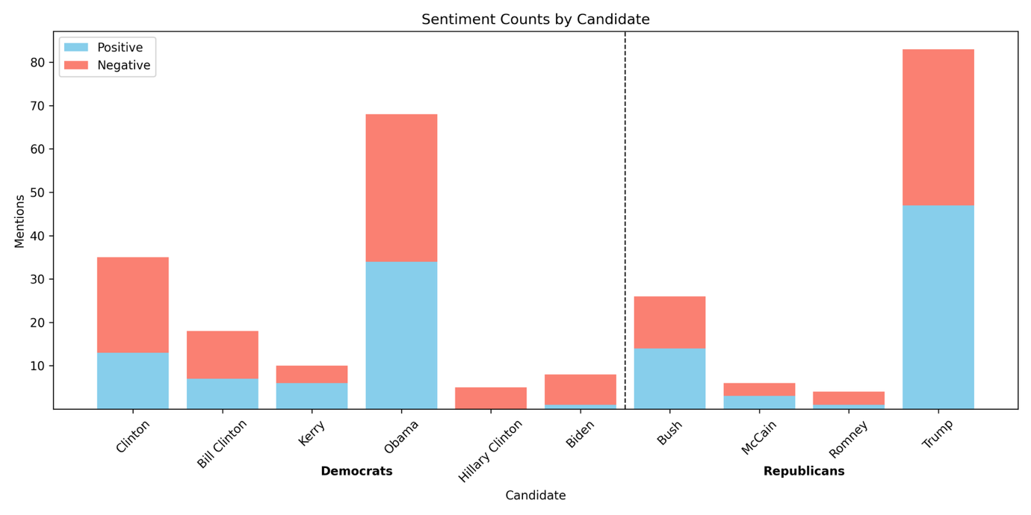

Top Sentence Blocks per Candidate

|  |  |  |
| --- | --- | --- |
| Label | Candidate | Sentence Block |
| Negative | Biden | We must rely on the grace of Christ to carry us through, and His sacramental presence and consolation. What if it gets worse as Biden and Harris have promised it would and lasts for four years or eight or the rest of our lives, God forbid. The Ephesus church also had a third attaboy from St. |
| Negative | Bush | It's the Economy, Stupid. This buzz phrase become very popular during the first President Bush's administration, and could easily be used today. Today let's take a look at God's spiritual economic plan for His people. |
| Negative | Clinton | When reporters hounded him about Clintonian lies, Stephanopoulos accused them of an excess of literalism. Stephanopoulos, to his credit, did tire of the Clinton lies and left the White House. CHALLENGE:Finding the truth, and acting on it, is an old problem. |
| Negative | Bill Clinton | You're sitting there thinking You just told us that you have no idea what a perfect gift is... and now you are going to preach about what one is. That seems like listening to Mickey Rooney pontificate about the dangers of being tall or Roseanne speaking on morality Michael Jordan giving a seminar on How To Survive on A Limited Income, Bill Clinton on Honesty... or Frank Gifford on Marital Fidelity. Now, before you get testy and negative I want you to know I am not speaking from personal experience of from my own wisdom. |
| Negative | Hillary Clinton | 83 a year after taxes. Those opposed to Hillary Clinton will point out that as a First Lady, Senator, and Secretary of State she never accomplished anything. Many accuse her of having an open marriage, allowing her husband the freedom to have affairs. |
| Negative | Kerry | You'll be congratulated for all your hard work, and you'll probably be given a job in the government somewhere that's your reward, if you want it, for working on the campaign for the winner. But if you were on John Kerry's campaign staff, then election day for you is not a good day. All your work didn't result in what you had hoped. |
| Negative | McCain | There were emails that went around saying that this child was not Palin's baby, but her daughter's child. Now, there is no evidence of that being true, it is just what some people were saying in an effort to hurt the McCain-Palin campaign. These emails are by no means alone. |
| Negative | Obama | This bad form, bad manners. It would be a little like Obama sending a White House page boy to greet Putin or the Queen of England. 5. |
| Negative | Romney | Conan O'Brien4. Today Mitt Romney visited a firehouse here in New York City. Of course, he was disappointed when he learned that the firehouse is not where you get to fire people. |
| Negative | Trump | Our nation will be in a mess. Those who oppose Trump declare that Islamic Mosques will be closed, inhibiting their freedom of religion. The press will be suppressed with only those in his favor getting access to him. |
| Positive | Biden | There are 4900 friends on my page. If you voted Biden say so. If not unfriend me. |
| Positive | Bush | B. Following this bold tradition President Bush made the following proclamation concerning thanksgiving on November 21, 2008:Thanksgiving is a time for families and friends to gather together and express gratitude for all that we have been given, the freedoms we enjoy, and the loved ones who enrich our lives. We recognize that all of these blessings, and life itself, come not from the hand of man but from Almighty God. |
| Positive | Clinton | A good teacher inspires a thirst for learning that lasts a lifetime. Bill Clinton said that on August 5, 1993 during a ceremony honoring inductees into the teacher's Hall of Fame. Henry Brooks Adams said, Teachers affect eternity, they can never know the full range of their influence. |
| Positive | Bill Clinton | A good teacher inspires a thirst for learning that lasts a lifetime. Bill Clinton said that on August 5, 1993 during a ceremony honoring inductees into the teacher's Hall of Fame. Henry Brooks Adams said, Teachers affect eternity, they can never know the full range of their influence. |
| Positive | Hillary Clinton |  |
| Positive | Kerry | -Rush Limbaugh and Bill O'Reilly are not the two prophets in the book of Revelation who come to prepare the way for Jesus' second coming. -You say, well I am not even a Republican, I am a Democrat well to you I say - John Kerry is not a male Mother Theresa. -Now some of you may be really looking forward to this series but I know what some of you are thinking. |
| Positive | McCain | And ultimately, do what is right and do it with love. John McCain on CourageSource: Fast Company magazine's First Impression newsletter 8-2-06 Copied from Preaching Today Courage is like a muscle, the late US Senator John McCain said. The more we exercise it, the stronger it gets. |
| Positive | Obama | And I do my very best to remember Him through His Son, Jesus Christ, and to focus on Him first and foremost in my life. Let us thank all of our veterans for their courageous service for America, and let us also remember to pray for our leaders, including President-elect Barrack Obama and his staff, that they might find themselves being led by God Almighty in their administration of this blessed nation. This is a time of healing and refocusing on our Lord, not a time of bitterness and negativity. |
| Positive | Romney | Jay Leno 6. Mitt Romney believes that marriage should be between one man and one woman. Which is better than his grandfather, who believed that it should be between one man and five women. |
| Positive | Trump | Psalm 72, NLT -Include in the bulletin for members:Dear Heavenly Father,I come before you with a humble and grateful heart. I ask you to lift up those who are seated in places of authority in our nation President Trump, those representing me in the United States Senate, in the U. S. |

### Positive/Neutral/Negative Sentiment Analysis:

The second model, finiteautomata/bertweet-base-sentiment-analysis, classified sentiment as positive, neutral, or negative. The candidates were then ranked by their difference in percent of mentions labelled positive and percent of mentions labelled negative. The following outputs were produced.

#### At Least 1 Candidate Mentioned in Sentence Block:

Candidate Sentiment Ranking

|  |  |  |  |  |  |  |  |
| --- | --- | --- | --- | --- | --- | --- | --- |
| Rank | Name | Party | Total Mentions | Neu % | Pos % | Neg % | Pos - Neg % |
| 1 | Kerry | Democrat | 19 | 57.89 | 26.32 | 15.79 | 10.53 |
| 2 | Bush | Republican | 51 | 56.86 | 21.57 | 21.57 | 0.00 |
| 3 | Trump | Republican | 118 | 52.54 | 22.03 | 25.42 | -3.39 |
| 4 | Obama | Democrat | 124 | 49.19 | 21.77 | 29.03 | -7.26 |
| 5 | McCain | Republican | 36 | 61.11 | 13.89 | 25.00 | -11.11 |
| 6 | Biden | Democrat | 22 | 63.64 | 9.09 | 27.27 | -18.18 |
| 7 | Clinton | Democrat | 60 | 50.00 | 11.67 | 38.33 | -26.66 |
| 8 | Hillary Clinton | Democrat | 10 | 50.00 | 10.00 | 40.00 | -30.00 |
| 9 | Bill Clinton | Democrat | 23 | 52.17 | 4.35 | 43.48 | -39.13 |
| 10 | Romney | Republican | 13 | 53.85 | 0.00 | 46.15 | -46.15 |

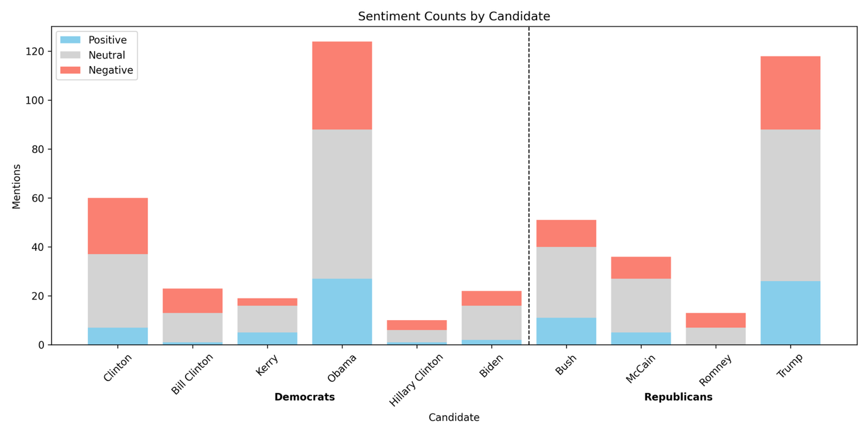

Top Sentence Blocks per Candidate

|  |  |  |
| --- | --- | --- |
| Label | Candidate | Sentence Block |
| Negative | Biden | OBAMA, and Joe Biden. Seems evil reports follow Obama from the first. Then President 45, Donald Trump. |
| Negative | Bush | When their breath departs, they return to the earth; on that very day their plans perish. In the words of one of my colleagues from a blog post this week, Donald Trump and Hilary Clinton are not gods. And I might add that neither is Barack Obama, or the Bushes, or any others. |
| Negative | Clinton | C. surrounded by officials and President Bill Clinton she declared I feel that the greatest destroyer of peace today is abortion. It is a direct war against the child, a direct killing of an innocent child. |
| Negative | Bill Clinton | C. surrounded by officials and President Bill Clinton she declared I feel that the greatest destroyer of peace today is abortion. It is a direct war against the child, a direct killing of an innocent child. |
| Negative | Hillary Clinton | The polls back this up as 71 of seniors say they are stressed and half of all adults are experiencing anxiety during this election season. On the other end of the age spectrum, according to one study, 1 in 4 millennials would rather the earth get hit by a giant meteor strike than have Donald Trump or Hillary Clinton in the White House. Here are some words that describe what many are feeling fear, anger, disgust, distrust, frustration, embarrassment, and hostility. |
| Negative | Kerry | Our country is divided into red and blue states and black and blue candidates. Both President Bush and Senator Kerry have practiced political polemics and have attacked each other's characters. One political commentator put it this way: Destroying the opposition rather than just winning the election seems to have become the trend in recent campaigns. |
| Negative | McCain | FinancesWe have a financial system that cannot seem to find its footing. Homes are being foreclosed onRetirement savings have been decimatedJobs are being lost by the thousandsThe Cost of living continues to riseThis is not only in America, but across much of the worldAdministration changeWe are in for a change of administration for sureWe are certain to have a president that scares a lot of people, whether that is John McCain or Barak Obama. Societal changesWe live in a different society that we did 10 years ago. |
| Negative | Obama | Let's call it for what it is baby killing. And Obama recently signed into law a bill that allowed, not only partial birth abortion but that the baby could be killed if it is alive outside the womb. God says that is an abomination. |
| Negative | Romney | I thought Romney would win in a landslide. With broken promises, high unemployment, economic woes, deficient sky high and the lies and deception of Libya I didn't think there was any way the majority of American's would vote for Obama. I didn't realize how effective his negative campaigning worked and how unaware, uninformed and uneducated the majority of the American public is. |
| Negative | Trump | Again a pause, Do you know, he added, I cannot, for the life of me, figure out where. Trump's words expose and express the sadness of the people of this world. All the people in Hollywood, all the people in politics, all the people with their big bank accounts don't have the answer or a clue as to what really gives meaning to life. |
| Positive | Biden | someone is going to win. Either Biden or Trump. Someone will walk away a winner. |
| Positive | Bush | B. Following this bold tradition President Bush made the following proclamation concerning thanksgiving on November 21, 2008:Thanksgiving is a time for families and friends to gather together and express gratitude for all that we have been given, the freedoms we enjoy, and the loved ones who enrich our lives. We recognize that all of these blessings, and life itself, come not from the hand of man but from Almighty God. |
| Positive | Clinton | A good teacher inspires a thirst for learning that lasts a lifetime. Bill Clinton said that on August 5, 1993 during a ceremony honoring inductees into the teacher's Hall of Fame. Henry Brooks Adams said, Teachers affect eternity, they can never know the full range of their influence. |
| Positive | Bill Clinton | A good teacher inspires a thirst for learning that lasts a lifetime. Bill Clinton said that on August 5, 1993 during a ceremony honoring inductees into the teacher's Hall of Fame. Henry Brooks Adams said, Teachers affect eternity, they can never know the full range of their influence. |
| Positive | Hillary Clinton | That role is saved for one Our savior. His name isn't Donald Trump or Hillary Clinton. As Christians we believe His name is Jesus. |
| Positive | Kerry | This filter also operates in a third and very important way. I am indebted to my ministerial colleague, Kerry Robinson, for opening up the final verses of our passage through a sermon I heard him give at Yellow Creek Lake Camp meeting a couple of years ago. He was speaking on this issue of holiness and he pointed out that we often focus on verses 22 and 23 but we forget about verses 25 and 26. |
| Positive | McCain | Even if we criticize them, we can acknowledge their efforts to serve their country. Senator McCain showed an incredible amount of support which revealed his character during his concession speech. When people started booing that Obama had won, he shut them down and said that response was completely inappropriate. |
| Positive | Obama | Let's honor the king. Barack Obama is our king. He is our president. |
| Positive | Romney |  |
| Positive | Trump | ILL. - Early in 1989, when Donald Trump's bank account was still bulging, a writer asked Trump the inevitable question about what horizons were left to conquer. Right now, I'm genuinely enjoying myself, Trump replied. |

#### Exactly 1 Candidate Mentioned in Sentence Block:

Candidate Sentiment Ranking

|  |  |  |  |  |  |  |  |
| --- | --- | --- | --- | --- | --- | --- | --- |
| Rank | Name | Party | Total Mentions | Neu % | Pos % | Neg % | Pos - Neg % |
| 1 | Trump | Republican | 83 | 53.01 | 26.51 | 20.48 | 6.03 |
| 2 | Bush | Republican | 26 | 65.38 | 19.23 | 15.38 | 3.85 |
| 3 | Obama | Democrat | 68 | 47.06 | 27.94 | 25.00 | 2.94 |
| 4 | Kerry | Democrat | 10 | 80.00 | 10.00 | 10.00 | 0.00 |
| 5 | Biden | Democrat | 8 | 62.50 | 12.50 | 25.00 | -12.50 |
| 6 | McCain | Republican | 6 | 50.00 | 16.67 | 33.33 | -16.66 |
| 7 | Clinton | Democrat | 35 | 40.00 | 17.14 | 42.86 | -25.72 |
| 8 | Hillary Clinton | Democrat | 5 | 60.00 | 0.00 | 40.00 | -40.00 |
| 9 | Bill Clinton | Democrat | 18 | 44.44 | 5.56 | 50.00 | -44.44 |
| 10 | Romney | Republican | 4 | 50.00 | 0.00 | 50.00 | -50.00 |

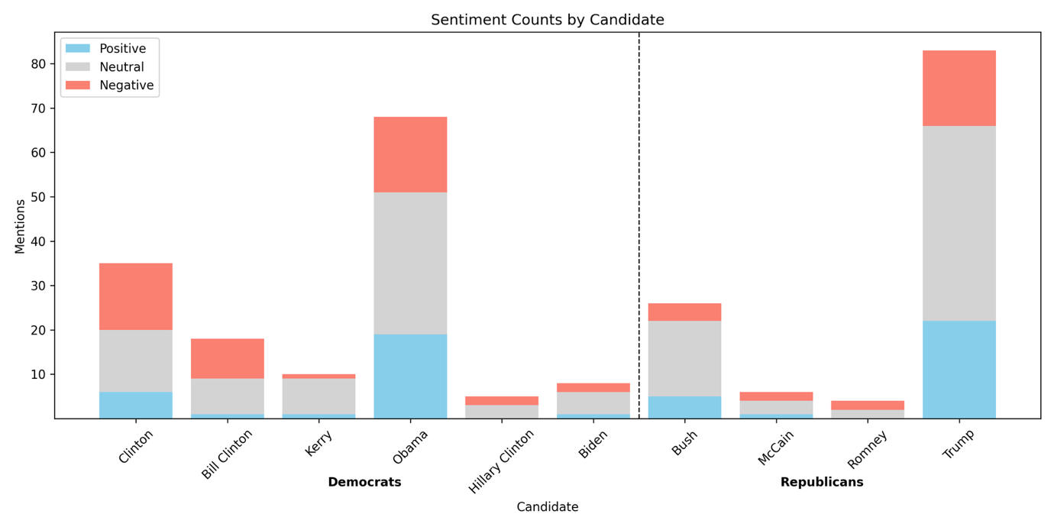

Top Sentence Blocks per Candidate

|  |  |  |
| --- | --- | --- |
| Label | Candidate | Sentence Block |
| Negative | Biden | We worry about our freedoms when the political winds change. Will Joe Biden and the Democrats clamp down on Christian freedom and condemn Biblical doctrines as hate speech. Or will we be able to maintain our freedoms to worship. |
| Negative | Bush | I hear religious scholars say, Islam is a peaceful religion. I heard President Bush recently say, Islam is a godly religion that has been hijacked. I respectfully disagree. |
| Negative | Clinton | C. surrounded by officials and President Bill Clinton she declared I feel that the greatest destroyer of peace today is abortion. It is a direct war against the child, a direct killing of an innocent child. |
| Negative | Bill Clinton | C. surrounded by officials and President Bill Clinton she declared I feel that the greatest destroyer of peace today is abortion. It is a direct war against the child, a direct killing of an innocent child. |
| Negative | Hillary Clinton | 83 a year after taxes. Those opposed to Hillary Clinton will point out that as a First Lady, Senator, and Secretary of State she never accomplished anything. Many accuse her of having an open marriage, allowing her husband the freedom to have affairs. |
| Negative | Kerry | You'll be congratulated for all your hard work, and you'll probably be given a job in the government somewhere that's your reward, if you want it, for working on the campaign for the winner. But if you were on John Kerry's campaign staff, then election day for you is not a good day. All your work didn't result in what you had hoped. |
| Negative | McCain | Obviously I couldn't finish it until I knew who won the election. Friends, this message is my effort, and would have been virtually identical had John McCain won the election, to see the hate stop among our citizens but even more among people of faith. I pray that I never see or hear about another situation like Mike and Buddy again. |
| Negative | Obama | Let's call it for what it is baby killing. And Obama recently signed into law a bill that allowed, not only partial birth abortion but that the baby could be killed if it is alive outside the womb. God says that is an abomination. |
| Negative | Romney | Conan O'Brien4. Today Mitt Romney visited a firehouse here in New York City. Of course, he was disappointed when he learned that the firehouse is not where you get to fire people. |
| Negative | Trump | Again a pause, Do you know, he added, I cannot, for the life of me, figure out where. Trump's words expose and express the sadness of the people of this world. All the people in Hollywood, all the people in politics, all the people with their big bank accounts don't have the answer or a clue as to what really gives meaning to life. |
| Positive | Biden | At one point, the interviewer spoke of how, under the economic proposals of his party, wealthier Americans would pay more taxes. Senator Biden defended the proposal saying, It's time to be patriotic time to jump in, time to be part of the deal, time to help get America out of the rut. Douglas K. |
| Positive | Bush | B. Following this bold tradition President Bush made the following proclamation concerning thanksgiving on November 21, 2008:Thanksgiving is a time for families and friends to gather together and express gratitude for all that we have been given, the freedoms we enjoy, and the loved ones who enrich our lives. We recognize that all of these blessings, and life itself, come not from the hand of man but from Almighty God. |
| Positive | Clinton | A good teacher inspires a thirst for learning that lasts a lifetime. Bill Clinton said that on August 5, 1993 during a ceremony honoring inductees into the teacher's Hall of Fame. Henry Brooks Adams said, Teachers affect eternity, they can never know the full range of their influence. |
| Positive | Bill Clinton | A good teacher inspires a thirst for learning that lasts a lifetime. Bill Clinton said that on August 5, 1993 during a ceremony honoring inductees into the teacher's Hall of Fame. Henry Brooks Adams said, Teachers affect eternity, they can never know the full range of their influence. |
| Positive | Hillary Clinton |  |
| Positive | Kerry | This filter also operates in a third and very important way. I am indebted to my ministerial colleague, Kerry Robinson, for opening up the final verses of our passage through a sermon I heard him give at Yellow Creek Lake Camp meeting a couple of years ago. He was speaking on this issue of holiness and he pointed out that we often focus on verses 22 and 23 but we forget about verses 25 and 26. |
| Positive | McCain | And ultimately, do what is right and do it with love. John McCain on CourageSource: Fast Company magazine's First Impression newsletter 8-2-06 Copied from Preaching Today Courage is like a muscle, the late US Senator John McCain said. The more we exercise it, the stronger it gets. |
| Positive | Obama | Let's honor the king. Barack Obama is our king. He is our president. |
| Positive | Romney |  |
| Positive | Trump | ILL. - Early in 1989, when Donald Trump's bank account was still bulging, a writer asked Trump the inevitable question about what horizons were left to conquer. Right now, I'm genuinely enjoying myself, Trump replied. |

## Topic Analysis

The topic model BERTopic was used to determine topics American pastors discuss within a 4-week window of election day. We first initialized the model with the "all-MiniLM-L6-v2" embedding model and a vectorizer model. The vectorizer model prevented certain stop words from being used to define a topic. We defined our list of stop words by common English words (such as “the”, “and”, “me”) and candidate names to discourage meaningless topics or topics about a specific election. We then fit BERTopic on a list of election docs, which were subtexts gathered from our sermon text dataset. Two methods were used to obtain the list of election docs, each described in 6.1 and 6.2 below.

Initially, we fit BERTopic with five times the intended final number of topics, then we used the “reduce_topics” method to reduce the initial topics to the intended number of final topics. Testing this approach against directly fitting the model with the intended final number of topics showed that it leads to more diverse topics. This is because the model initially captures more detailed distinctions between topics before merging them based on similarity. We found greater consistency in the final topics using this approach as well. We also attempted to fit a separate topic model on the docs assigned to the outlier topic, but the topics did not differ significantly from the theme of the outlier topic, so we did not include this extension.

A topic label was generated for each topic by providing gpt-4o with the following information from BERTopic: topic name, top 10 words, and top 10 subtexts assigned to the topic, ranked by probability of assignment to the topic. The generated label, top 10 words, and top 10 subtexts are included below for each topic.

Next, we transformed a list of election Tuesday docs, gathered with the same method used to gather the election docs, to the topics. That is, each election Tuesday doc was assigned to the topic it best fit to. Note that the election docs are a subset of the election Tuesday docs. For each sermon text, we then determine all topics mentioned in the text by checking the assigned topic of each election Tuesday doc that is a subtext of the text.

For each topic, the following regression is then run

mentions = β0​ + β1​(pre-Tuesday dummy) + β2​(election-year dummy) + β3​(interaction) + ϵ

where, for each sermon text

* mentions = 1 if the topic is mentioned in the sermon text, 0 otherwise
* pre-Tuesday dummy = 1 if the sermon is given before the nearest election Tuesday, 0 otherwise
* election year dummy = 1 if the sermon is given in an election year, 0 otherwise
* interaction = 1 if the sermon is given before the nearest election Tuesday and in an election year, 0 otherwise

The resulting regression coefficients and statistics are displayed in a table below, along with plots of the predicted and the actual mentions aggregated by week within the analysis window.

### Docs from Pattern Matching

We first approached gathering docs for the topic model using pattern matching. Like in the sentence model, we used sentence blocks to provide more context for BERTopic. If the pattern detected a candidate keyword or election keyword (e.g. “Trump” or “vote”), then a sentence block was formed around the detected sentence and added to the list of docs.

Below are the regression coefficient and statistics table, aggregated mention counts plots, and topic information for each topic using the docs gathered from pattern matching.

|  |  |  |  |  |  |  |  |  |  |
| --- | --- | --- | --- | --- | --- | --- | --- | --- | --- |
| **Topic** | **Name** | **pre-Tuesday dummy** | **election year dummy** | **interaction** | **Constant** | **Mean Dep. Var.** | **Std. Dev. Dep. Var.** | **Adj. R²** | **N** |
| all | All Topics | 0.00450 (0.00449) | 0.0167** (0.00816) | 0.0386*** (0.0112) | 0.121*** (0.00333) | 0.1311 | 0.3376 | 0.0027 | 26789 |
| outlier | Religion and Politics in America | 0.00790** (0.00391) | 0.00455 (0.00683) | 0.0305*** (0.00960) | 0.0863*** (0.00287) | 0.0950 | 0.2932 | 0.0017 | 26789 |
| 0 | Christian Faith and Political Engagement | 0.00326* (0.00196) | 0.0104*** (0.00393) | 0.0108* (0.00562) | 0.0195*** (0.00141) | 0.0245 | 0.1544 | 0.0022 | 26789 |
| 1 | Presidential Leadership and Faith | -0.00462** (0.00197) | -0.00551* (0.00324) | 0.0135*** (0.00456) | 0.0232*** (0.00154) | 0.0211 | 0.1436 | 0.0003 | 26789 |
| 2 | Faith and Civic Responsibility in Elections | 0.00113** (0.000518) | 0.00605*** (0.00183) | 0.00515* (0.00282) | 0.000937*** (0.000312) | 0.0033 | 0.0572 | 0.0044 | 26789 |
| 3 | Church Leadership and Ministry | -0.00205** (0.000967) | 0.00245 (0.00212) | 0.00523* (0.00295) | 0.00594*** (0.000784) | 0.0058 | 0.0761 | 0.0009 | 26789 |
| 4 | Supreme Court and Judicial Decisions | 0.000513 (0.000790) | 0.00107 (0.00151) | 0.00346 (0.00231) | 0.00312*** (0.000569) | 0.0040 | 0.0631 | 0.0005 | 26789 |
| 5 | Pro-Life and Abortion Debate | -0.000699 (0.000592) | 0.000609 (0.00124) | 0.00573*** (0.00207) | 0.00219*** (0.000477) | 0.0025 | 0.0503 | 0.0013 | 26789 |
| 6 | Economic Crisis and Government Response | 0.0000794 (0.000290) | 0.00145 (0.000954) | 0.00316* (0.00164) | 0.000416** (0.000208) | 0.0011 | 0.0329 | 0.0019 | 26789 |
| 7 | Israel and Divine Providence in Global Politics | 0.000780* (0.000425) | 0.00310** (0.00134) | -0.00111 (0.00175) | 0.000625** (0.000255) | 0.0015 | 0.0391 | 0.0006 | 26789 |
| 8 | Same-Sex Marriage Legislation and Debates | -0.0000280 (0.000415) | 0.000461 (0.000865) | 0.00271* (0.00149) | 0.000937*** (0.000312) | 0.0013 | 0.0361 | 0.0006 | 26789 |
| 9 | Biblical Leadership and Election Narratives | 0.000226 (0.000195) | 0.00129 (0.000813) | -0.00128 (0.000897) | 0.000104 (0.000104) | 0.0003 | 0.0183 | 0.0002 | 26789 |

Standard errors in parentheses

* p<0.1, ** p<0.05, *** p<0.01

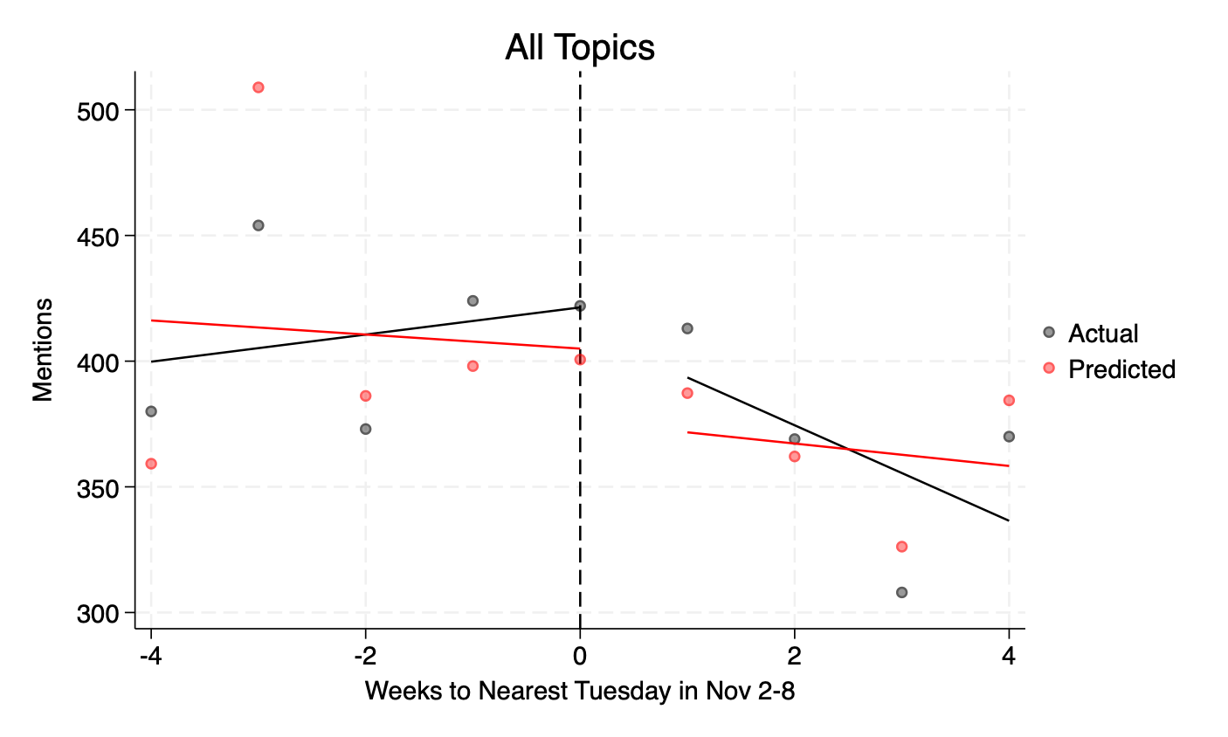 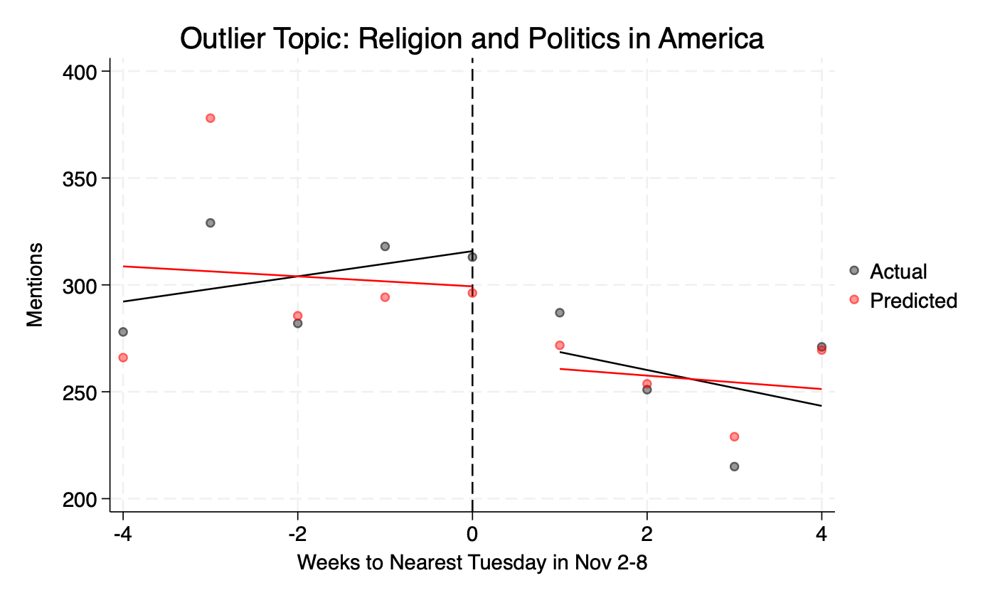

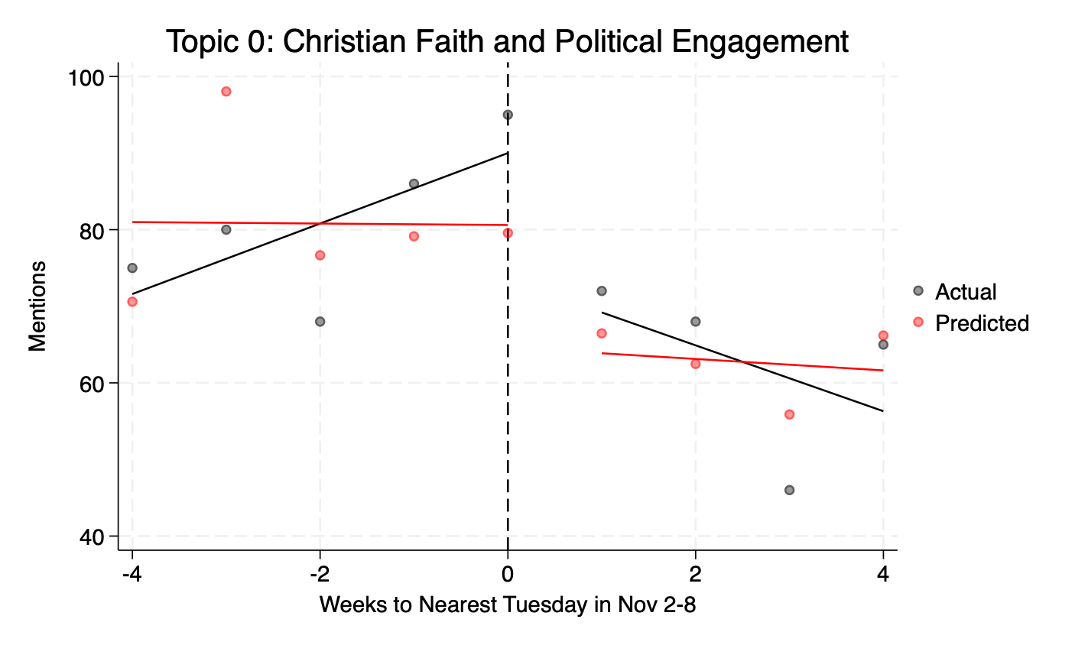 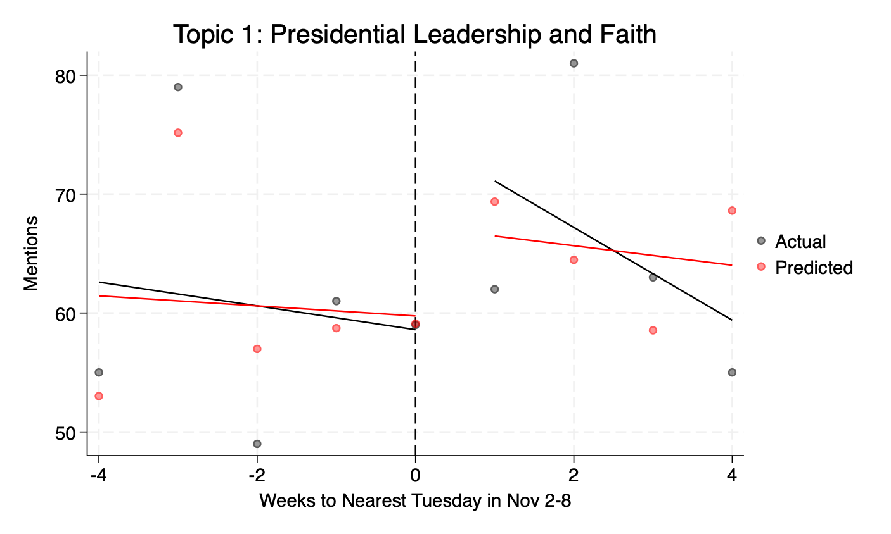

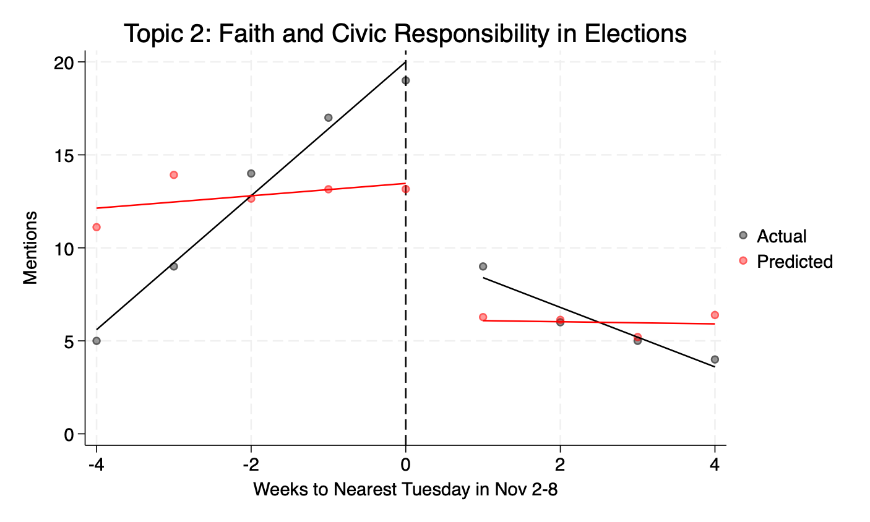 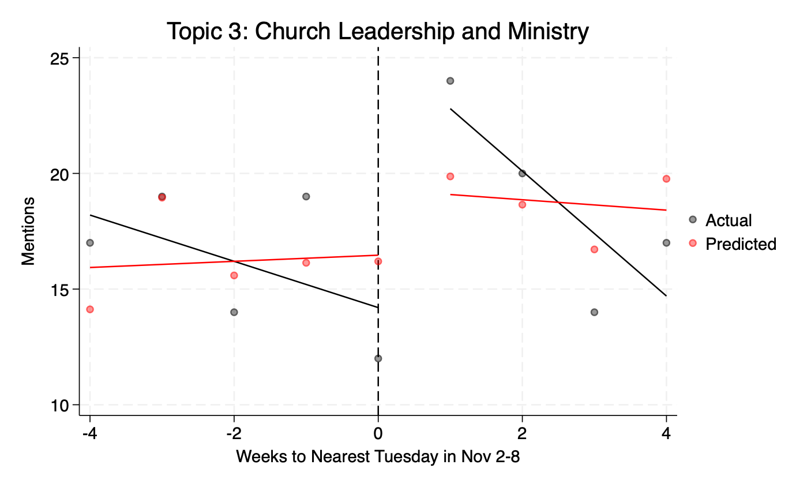

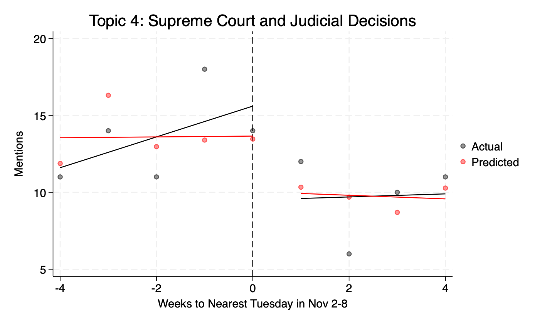 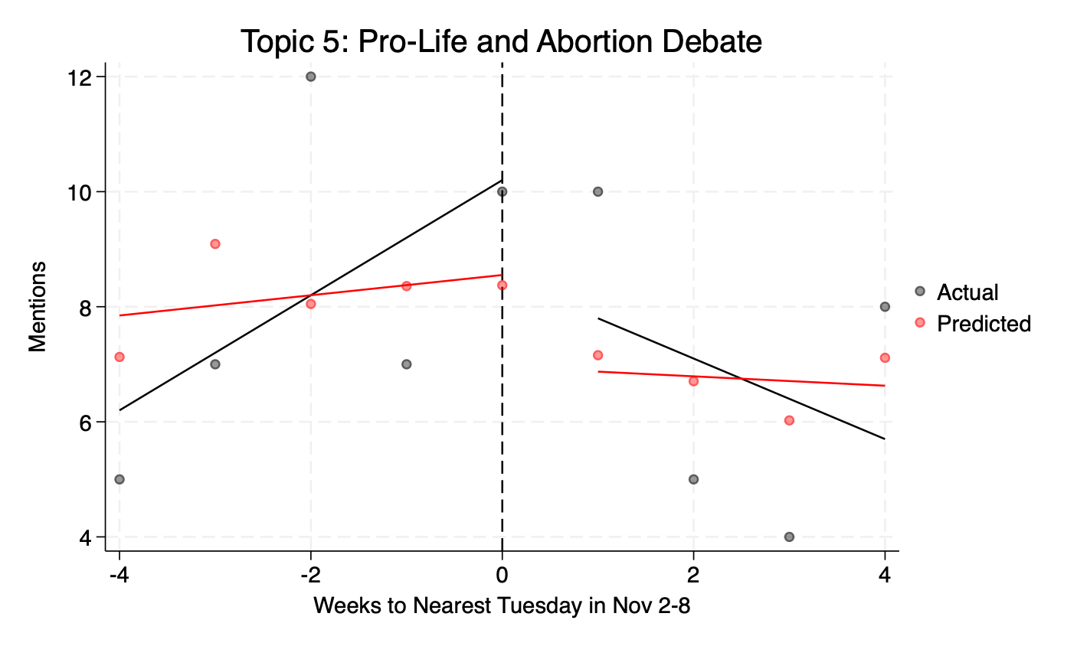

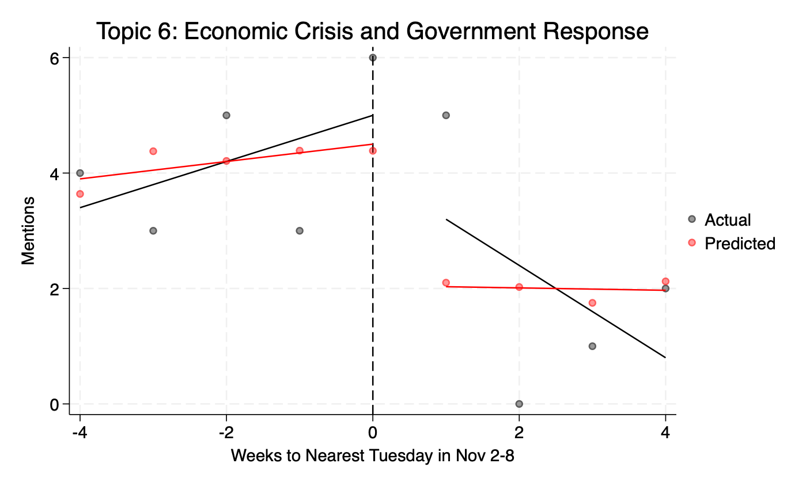 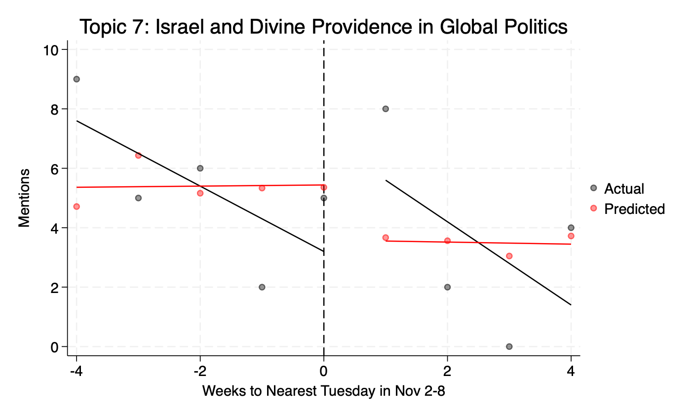

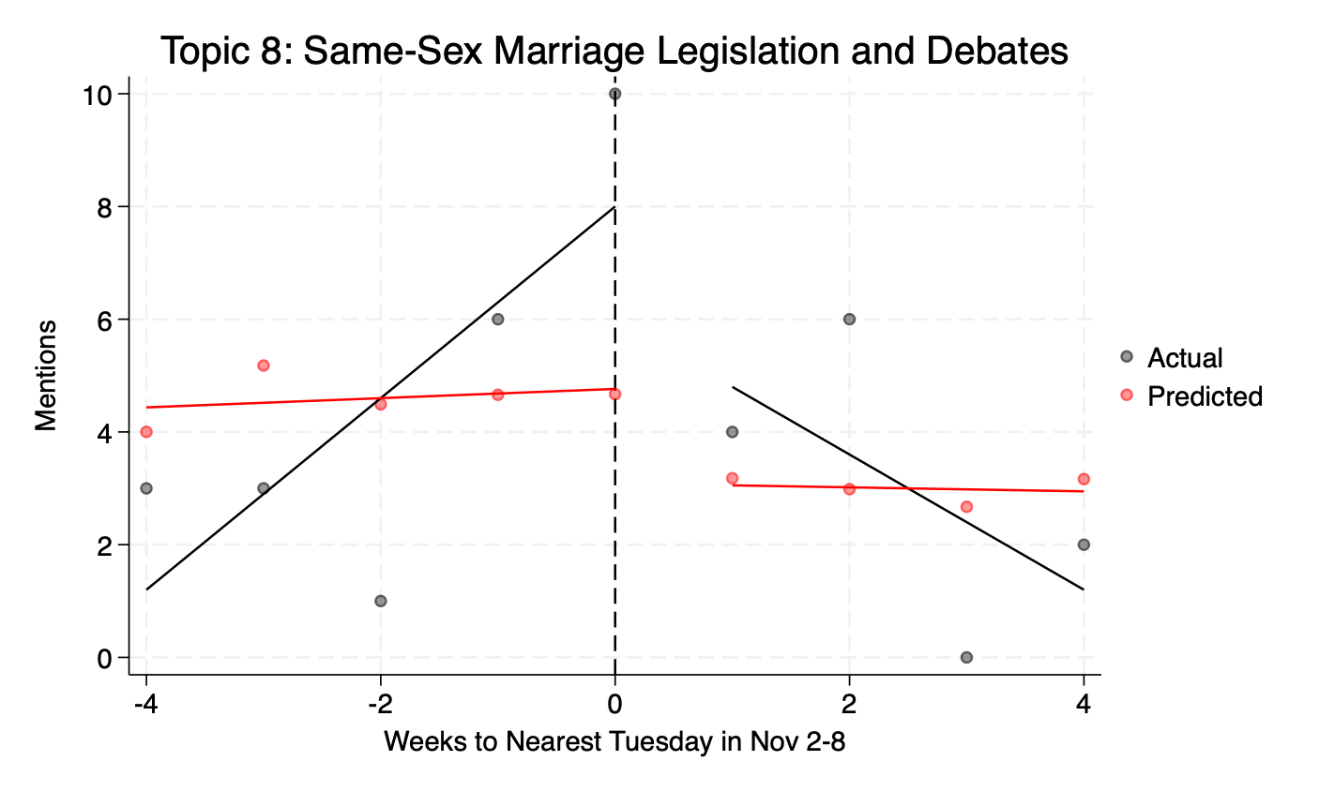 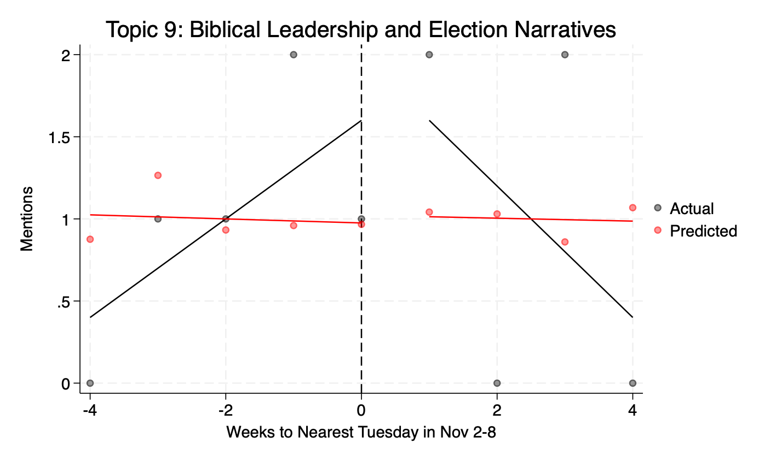

Outlier Topic: Religion and Politics in Elections

Top 10 words: god, vote, president, election, from, people, can, would, jesus, don

Example sentences:

1. Without the direction of the Holy Spirit, this concern can easily turn to slander, for some times there is a fine line between voicing a concern and gossip, and between help and hurt. George Bush the first made a trip to Australia during his term in office, when getting off the plane he decided to flash the reporters, tv crews and bystanders what he thought was the peace sign. What he accomplished was flying the entire nation the bird.
2. OK, ask your relatives to help you, I have my own problems. Ha, I remember Joe Biden gafe during an electoral meeting, asking a guy in wheel chair to stand up. Apply... church-sinner-insensitive speaker/pastor... I am sure that the crippled beggar knew about Jesus.
3. Raising taxes. What politician will do this. No one.
4. Revelation 18 our Scripture Reading By the way, some put in the bank this big paper for retirement, and they will receive this a small one Loosing value Just some basic principles - economy This is not a lecture in economics. But we need this in order to understand something Come on Pastor, you are an alarmist Everything is fine, the crisis is over, they voted a plan and that's it. Let's here some nice things about Jesus love and forgiveness No, I am not an alarmist, I am a realist And I now Jesus loves me and loves you, because this is the reason He is warning us today.
5. GC 446 National Ruin Follows National Apostasy Do you thing it is impossible for this country to abandon the principle of God, giving up the first amendment. Look, in one session the Congress voted a very unpopular law One trillion bail-out from our money 8 minutes bam. Both candidates united and saying yes They are aware of what Main Street wants.
6. When I was a boy I got involved in stamp collecting. The hobby got a boost in the 1940's because President Roosevelt was an avid stamp collector and used the hobby as a means of escape from the burdens of his office. Well, the bug bit me when I was about nine years old.
7. Proverbs 6:23 For the commandment is a lamp; and the law is light; and reproofs of instruction are the way of life:In just a week our country will be making the most serious decision that it has made in my lifetime when we make the choice about who will lead our nation for the next four years. Not only will we make a decision about who will be president but there are thousands of national, state and local elections that will impact our lives. I've had numerous individuals who have asked me personally about how we should decide to vote, and who we should vote for and what a Christian's responsibility is in this case. Part of being a good Christian is being a good citizen and that means doing certain things set forth in Scripture.
8. What we do with the light we have is important. You and I have a responsibility to do what President Abraham Lincoln said at his second inaugural, with firmness in the right as God gives us to see the right Bro. Roy Harris writes that, The church should be the light that pierces the darkness of a nation in moral decline.
9. Why do I tell you about that. Did I tell you about that interview to get you all riled up against our President-elect. No.
10. We may choose to bind ourselves to one another in ways that are redemptive, powerful, and wonderful. We are a motley crew; but we can elect to be in chains, not as an imprisonment, but as a commitment. Let me call the roll, with Paul's help:The essence of prison is isolation.

Topic 0: Christian Faith and Political Engagement

Top 10 words: god, elect, jesus, election, christ, paul, people, faith, pray, christians

Example sentences:

1. Now we may wish that the Bible was more specific but we need to remember one thing, our chief interest should be in the area of spiritual order not secular or social order. That is not to say that you should not exercise your right to vote, you should be registered to vote and then go to the polls and vote. While there are issues that the Bible does not speak about, there are things that we can apply Biblical principles to.
2. While there are issues that the Bible does not speak about, there are things that we can apply Biblical principles to. We have an obligation to take a stand for morality and righteousness and in my mind that would include being informed about what candidates stand for and voting for those who support Biblical values and virtues. First let's consider the light that we have in the Word of God and what it provides.
3. This decision should transcend party identification, the latest poll, how our peers or family members plan or the suggestions of the media liberal or conservative. There should be something stronger guiding our thinking We should vote for candidates who give evidence in their lifestyle and stated position which most closely reflects our own biblical and personally held beliefs. b.
4. John 15:16Ye have not chosen me, but I have chosen you, and ordained you, that ye should go and bring forth fruit, and that your fruit should remain: that whatsoever ye shall ask of the Father in my name, he may give it you. A much misunderstood verse the Bible concept of the elect and a subject for another message, but suffice it to say that the word chosen DOES NOT mean chosen without choice. We each have a free will.
5. It expresses a past activity' with results that continue in the present'. Once you became one of the elect , your inheritance has been reserved in heaven. An Invaluable Inheritance; sealed as Ephesians 1:13-14 says with the promised Holy Spirit, who is a deposit guaranteeing our inheritance until the redemption of those who are God's possession.
6. I. We understand the purpose of His purchaseA God's choosing of sinnersThe term elect in 1. 1 reminds us that God chooses us.
7. Regarding salvation and assurance, there are three groups of people: 1 those who are sure but not secure; 2 those who are secure but not sure; and 3 those who are secure and sure. As we learn to live in the Spirit, the changes He will then bring about in our lives will enable us to not only be secure in our salvation, but sure of our salvation, as Peter tells us in 2 Peter 1:10-11 NIV , Therefore, my brothers, be all the more eager to make your calling and election sure. For if you do these things vs.
8. , When there is a terror attack or a school shooting, we can either go buy a gun and a bunch of ammunition or we can pray. , When we have a presidential election in which we are forced to choose between two ungodly candidates, we can throw up our hands in despair or we can pray. If Jesus is genuinely my Lord, then prayer will be my first response, not my last resort.
9. In order to impact our world, we have to first stand on the truth if we hope to saturate those around us with the truth. Please turn in your Bible to Titus 1:1-4 and follow along as I read: Paul, a servant of God and an apostle of Jesus Christ for the faith of God's elect and the knowledge of the truth that leads to godliness--a faith and knowledge resting on the hope of eternal life, which God, who does not lie, promised before the beginning of time, and at his appointed season he brought his word to light through the preaching entrusted to me by the command of God our Savior, To Titus, my true son in our common faith: Grace and peace from God the Father and Christ Jesus our Savior. Let's look at seven ways to live like Christians while we live in Crete.
10. He also knew his purpose. He was a servant and an apostle for the faith of God's elect. Paul's mission was to fortify the faithful and grow them into godliness.

Topic 1: Presidential Leadership and Faith

Top 10 words: president, states, united, day, shall, god, lord, from, first, said

Example sentences:

1. I don't know if you've figured out who that interview was with. But it was conducted by a Chicago Sun-Times religion reporter on March 27, 2004 as she sat down in a local coffee shop with then State Senator Barack Obama. Why do I tell you about that.
2. Ill. it's a good thing that Abraham Lincoln wasn't a quitter...losing 9 elections, losing his fianc e, having a nervous breakdown, going bankrupt twice...and all before he became president and ended the atrocity of slavery. A lesser man would have given up long before.
3. We ought to look forward to the coming of Christiii. The Rescue of the Rapture - 1 Thessalonians 4:16-18 - 16For the Lord himself shall descend from heaven with a shout, with the voice of the archangel, and with the trump of God: and the dead in Christ shall rise first: 17Then we which are alive and remain shall be caught up together with them in the clouds, to meet the Lord in the air: and so shall we ever be with the Lord. 18Wherefore comfort one another with these words.
4. The second greatest tragedy of our nation is that he never sat in the White House. The first greatest is that Clinton did. MacArthur said, In war there is no substitute for victory.
5. s dream. We have decided as a country that there is more to a person than the color of the skin, and elected him president. And I say, Good for us.
6. He is sleeping, Mr. President. He said not to disturb him.
7. No, Mr. President. I work for him, not you.
8. I work for him, not you. When I called the President back, he could scarcely control his pleasure. Tell that woman I want her here in the White House.
9. 2 Beloved, now are we the sons of God, and it doth not yet appear what we shall be: but we know that, when he shall appear, we shall be like him; for we shall see him as he is. 1 Th 4:16 - 18 For the Lord himself shall descend from heaven with a shout, with the voice of the archangel, and with the trump of God: and the dead in Christ shall rise first: Then we which are alive and remain shall be caught up together with them in the clouds, to meet the Lord in the air: and so shall we ever be with the Lord. Wherefore comfort one another with these words.
10. 15For this we say unto you by the word of the Lord, that we which are alive and remain unto the coming of the Lord shall not prevent them which are asleep. 16For the Lord himself shall descend from heaven with a shout, with the voice of the archangel, and with the trump of God: and the dead in Christ shall rise first: 17Then we which are alive and remain shall be caught up together with them in the clouds, to meet the Lord in the air: and so shall we ever be with the Lord. 1 Thes.

Topic 2: Faith and Civic Responsibility in Elections

Top 10 words: vote, election, god, candidate, voting, candidates, people, been, from, can

Example sentences:

1. Educate ourselves about where the candidates stand on the issuesAgain, I quote Bro. Roy Harris: Determining who we should vote for should not be a hard decision to make. This decision should transcend party identification, the latest poll, how our peers or family members plan or the suggestions of the media liberal or conservative.
2. Maybe your are sitting here tonight and you think God cannot possibly use me. If that is your thinking then you are a prime candidate for God to use you, just surrender to His leadership.
3. 2. Value your freedomsIn many cases they gave their all so you could have the freedom of speech, freedom to bear arms, freedom to vote, freedom to worship, freedom to assemble and so on. When you devalue those freedoms, or when you don't take advantage of them you make it seem like their service, their sacrifice was in vain.
4. , What would have happened if Daniel, had not interceded on their behalf. , Is there any kind of principle we can take from this story, and apply to our own situation as Americans, on the day after a difficult election. , Could it be that we had better own up, and identify with the sins of our nation, so that we can more effectively, intercede on it's behalf.
5. The name of our state is Chicago. not Illinois We have allowed Chicago to vote for our state. We have allowed Chicago to become the acting capitol of our state.
6. Follow the example of the disciples in the Upper Room. Ask the Lord to show you which candidate He has chosen for each position, and then listen for the answer. Don't wait until Tuesday as you are heading into the voting booth to ask. Do it now, today, if you haven't already done so.
7. That is the only true test of wisdom there is. Take the time to go to websites like Vote Smart and look up each candidate's voting record, what committees or groups they belong to, what their stands are on important issues, etc. This is the fruit their lives are producing.
8. 4. Policies and Personal BenefitsThe fourth concept to keep in mind when trying to determine who to vote for is the policies each candidate proposes and how they affect you personally. This seems like common sense.
9. This seems like common sense. Most people look at how each candidate would benefit them personally, and vote accordingly. For example if a person has recently been affected by layoffs, they will be interested in which person is promising jobs and how they plan to increase employment.
10. For example if a person has recently been affected by layoffs, they will be interested in which person is promising jobs and how they plan to increase employment. Or someone who owns a small business may vote for the candidate with the proposal that benefits them most. While this seems natural, I want to remind you of something.

Topic 3: Church Leadership and Ministry

Top 10 words: church, president, pastor, minister, candidate, years, irs, churches, god, sbc

Example sentences:

1. Everything the church does, every energy that it expends, needs to be pointed toward this one thing ... redeeming and completing human beings. To paraphrase Bill Clinton's famous poster, It's the people, stupid. The seductive thing, you see, about church is that it is so easy to get lost in its activities and its traditions.
2. Bro. Rick Evans, Pastor of Dalraida Baptist in Montgomery, was the president. He told the story of his youngest daughter bringing him to such a place in his life that he knelt and prayed, Lord, I've done all I can.
3. - This same issue came up a few days ago. - It looks to be slated in June of 2021, the SBC May vote on a name change to greatcommission Baptist's. Q- What's the purpose of doing that.
4. Next, they each filled out an initial questionnaire and then met with our 5 elders for a deacon interview. Then they were recommended them to the church, and our church voted to call these men as deacons. Then they filled out a 6-page theological questionnaire and they each met with our active deacons and elders for an ordination council.
5. Dr. Rainer is the president of Lifeway Christian Resources. Lifeway is the publisher and bookstore that supplies much of the resources, Bible studies, curriculum - even our youth camp that our teenagers attend is under the umbrella of Lifeway.
6. Peter Cartwright - He was a circuit riding preacher in the US in the early 1800's who personally baptized over 12,000 people. On one occasion he was told that president Andrew Jackson was in the crowd that day when he was preaching and that it might be wise to tone down his message. When Cartwright rose up to preach he began his message with these words: I understand Andrew Jackson is with us today.
7. All in God's perfect timing. - Joe Stowell President of Cornerstone University, Grand Rapids, Michigan All history is in God's hand. He knows the best season for sending help to His church and new light to the world.
8. Dr. Jeffery, who is the president of BBC in Clark's Summit, Pa. , and the keynote speaker at this year's MARBC State Meeting gave a great illustration of the importance of a strong root system.
9. Gabe Lyons runs a Christian ministry called The Fermi Project, whose goal is to help the Church make a positive impact on a culture that, by and large, wants nothing to do with Christianity and the Church. David Kinnaman is the president of the Barna Group, which has been leading the way for many years in Christian research regarding the culture and how to impact it. So you see, the book isn't a collection of thoughts put together for the sake of trying to paint the Church in a bad light for the sake of denigrating it.
10. Period. Steve Farrar, president of Strategic Living Ministries in Dallas, Men of Integrity, Vol. 1, no.

Topic 4: Supreme Court and Judicial Decisions

Top 10 words: court, supreme, justices, judge, president, next, hear, unjust, avenge, put

Example sentences:

1. 6 THE SIGNATURE By Christ Jesus. A My check My signature Rockefeller's signature Donald Trump'ssignature. Jesus gives us a blank check with His signature on it and says, Just fill it inwith what you need, and I will provide it for you.
2. It will go down as a monumental day in constitutional law. Their decision on the case will not be made until June, but court observers and experts believe the 9 justices are split right down the middle, with Justice Kennedy likely making the deciding vote. In the course of the oral arguments, the justices questioned the attorneys on both sides of the issue.
3. On Tuesday, Douglas County District Court Judge Marlon Polk ruled that under state law a plaintiff must have access to the defendant for a lawsuit to move forward. Given that this court finds that there can never be service effectuated on the named defendant this action will be dismissed with prejudice, meaning the case is over, it can nerve be filed again Mind Full- We are mindful of floods, earthquakes, hurricanes, tornados, plagues, famines, droughts, wars, birth defects, fuel costs, home foreclosures unemployment, financial crises, next week election- Being mindful is the problem- We lose sleep because our minds are full. - We've already got too much stuff in our heads.
4. 5b. So they set a trap for him knowing that his love for God would trump anything else in this world. I want you to get this.
5. They don't deal with individual defendants at all. Even the president can save a life, but he cannot take one. You could say that the people, the ones who elected the legislature and provided the jury are the ones to decide.
6. It is shocking to me that a Supreme Court that is supposed to be one third of the powers that govern the United States is the overwhelming power that governs the land. The supreme court can override the votes in congress, the very vote that is supposed to in turn be for the people. This isn't a democracy, it is nothing more than a country run by judges who are satanic agents of darkness who twist and bend the very constitution that was meant to establish and cherish biblical principles that our founders saw.
7. Making Godly DecisionsColossians 3:1-17Over the next 72 hours you who sit here will be making several crucial decisions. Decisions crucial to our nation who will be our next president. What will the character of our Supreme Court be what will the laws of the land be about religious liberty, Abortion, Partial Birth Abortion, Euthanasia, the definition of marriage, public prayer and a host of other things critical to the fabric of our nation.
8. 9But if anyone does not have them, he is nearsighted and blind, and has forgotten that he has been cleansed from his past sins. 10Therefore, my brothers, be all the more eager to make your calling and election sure. For if you do these things, you will never fall, 11and you will receive a rich welcome into the eternal kingdom of our Lord and Savior Jesus Christ.
9. 5. It's Obama's fault. 6.
10. 20 But if you have not acted in good faith, then may fire come out from Abimelech and devour the people of Shechem and Beth-millo; and may fire come out from the people of Shechem and Beth-millo and devour Abimelech. We need , To make the voting booth into a prayer booth. , To make God's choice our choice.

Topic 5: Pro-Life and Abortion Debate

Top 10 words: abortion, life, pro, baby, research, cell, stem, issue, babies, unborn

Example sentences:

1. Once conception occurs nothing else is added by either the mother or father genetically to the baby, by the way, when a mother is pregnant she says she is having a baby not a fetus. Here are 10 questions you never hear a pro-choice candidate asked by the media:1. You say you support a woman's right to make her own reproductive choices in regards to abortion and contraception.
2. Of the 93 Members of the Freshman Class at least 77 are committed to defending the unborn. Almost every poll shows that Americans are becoming increasingly pro-life but in some recent elections we haven't voted that way. That has to change.
3. INTRODUCTION: This last four years has been a time of a semblance of a move back to the way America was founded. We have seen the challenge by our President to move away from immorality, and efforts to make the home and family strong. In the last 30 years we have seen more than 40 million babies aborted.
4. -- Harrison Hickman, pollster for the National Abortion and ReproductiveRights Action League3. Both presidential candidate believe that life begins at conceptionB. A perspective on the slaughter of American children1.
5. a culture of life. Hot topics in this 2004 election are abortion and embryonic stem cell research issues. You probably know that 4,000 abortions a day are performed in the United States.
6. What about abortion. No one seems to be talking about abortion this election cycle. Where do the candidates stand on abortion.
7. But we have grown cold. We ought to march in Right to Life marches and vote only for those politicians who oppose abortion. That is one of my litmus tests of a Politian.
8. There are some of us under no circumstance will compromise some issues. I could never support a candidate who supports abortion. Let's call it for what it is baby killing.
9. When both parties agree that abortion should be rare, what is going on here. There is a lot at stake in this upcoming election regarding abortion. The stakes in the 2004 election:-Will you be required to pay for abortions abroad and in America. -Will parents be notified if their girl wants to have an abortion.
10. The abortion issue is a great issue in the presidential discussions. Obama when asked his views, gave the politically soothing answer: many women have suffered and it's beyond my pay grade to make that decision of when life begins. McCain, when asked when life begins, gave the simple answer, At Conception. Even when everyone goes against you at work or at school or in your neighborhood, never be afraid to stand up for the truth.

Topic 6: Economic Crisis and Government Response

Top 10 words: money, president, system, issue, economy, debt, bank, crisis, mr, from

Example sentences:

1. But this is nothing comparing with Social Security and Medicare financial disaster Earlier this year, Richard W. Fisher, the President and Chief Executive Officer of the Federal Reserve Bank of Dallas offered the following:Fast forward 70 or so years and ask this question: What is the mathematical predicament of SOCIAL SECURITY today. Answer: The amount of money the Social Security system would need today to cover all unfunded liabilities from now on - what fiscal economists call the infinite horizon discounted value' of what has already been promised recipients but has no funding mechanism currently in place is 13.
2. Senate Banking Committee Chairman Chris Dodd said on ABC's Good Morning America, some days ago that we're literally maybe days away from a complete meltdown of our financial system, with all the implications, here at home and globally. An extraordinarily costly plan was voted that is intended to address just the current crisis but it is not working yet as the President reasured us. This is the world that we live in.
3. Everybody wants to live as if they can afford everything. Borrowing more and more, spending more and more which means that the future is uncertain the use of this word - uncertain good politician. The US Government don't have enough money to pay for everything; SS, Medicare, the war, federal institutions... And no politicians dare to raise the taxes.
4. I anticipate that US will walk away from its debt. New rules will be voted overnight and an authoritarian government will be ready to enforce them Sounds impossible. A year ago it was unthinkable to conceive how the Democrats and Republicans will come together, in unity to vote a law nationalizing the banks, a law that 80 of citizens is against it. Revelation 13 is right here Embargo; nobody sell or buy without belonging to their system.
5. -The economy. -The election. -Or something else going on in your life.
6. Crumbling economy -- that goes in the box. Election worries -- they go in the box. Family problems, health issues, struggles with sin: Put them all in the box.
7. We all have the same amount of time. Whether we are penniless or whether we happen to be the richest person on earth, whether we are young or old, single or married, employed or without a job, an adolescent in school or the President of the United States of America-we have exactly the same amount of time page 67. From a sermon by Michael McCartney, Energy Conservation, 1/28/2010b.
8. And the money that is spent. Wall Street, Amazon, stores across the country, even the President will measure the progress of our country based on the amount of money we spend at this time of year. This was just released:Fortune magazine reported that this year consumers spent a record 69 billion dollars between Thursday and Sunday----during the long Thanksgiving Holiday weekend.
9. Bank and investment bank failures, business bankruptcies, the threatened collapse of Ford and GM, home foreclosures, a falling stock market, a falling dollar, a rising unemployment rate and the list goes on and on. A cartoon in the Houston Chronicle following the election summed up the situation our nation is facing quite well. It depicts a messenger delivering Barack Obama a message. The man said: Mr.
10. The man said: Mr. Obama, I have good news and I have bad news. Barack asked what the good news was, to which the messenger replied: You've been elected president. Barack then asked: And what's the bad news.

Topic 7: Israel and Divine Providence in Global Politics

Top 10 words: israel, god, america, nations, nation, saul, though, hope, land, truman

Example sentences:

1. But warning If America is not careful how it treats Israel Genesis 12: 3 could come upon us over night. What American politician were these words spoken to. You might be president one day. You will make mistakes, and God will forgive you.
2. God tells Israel that He didn't choose them because they are the majority. Compared to other nations they would not win the popular vote. It's not because they were bigger and it's NOT BECAUSE THEY WERE BETTER.
3. It seems as though God is slowly but surely removing His Hand from our country. And let me say right here, that if we ever elect government officials that don't want to stand with Gods chosen people Israel, we're on our way to certain destruction, I believe the only reason God has blessed our nation the way He has in the passed is because of our stand with Israel. Listen, Israel don't necessarily need us, but we surely need Israel.
4. Reason 2: Jews Are God's Chosen People. It's what many theologians call Divine Election. In 1993 the Soviet ambassador to the United Nations said, Zionism is a racist creed absurd ideology.
5. God uses someone you would least expect to be an instrument of God- Cyrus, Persian Emperor- Occupier, Representative of the evil power of the time- Non-Believer- Iranian Terrorist- Ahmadinejad- God picks the evil one to help himThe Living Message here is:- Not just a good God- Disappointing for those suffering from a deep desire for harmony- In God's world struggle is inevitable- Yesterday I blessed a marriage of a young couple- Maybe you will meet them next week- they told me he needs to be straightened out by her- they faced hardships and they will again- other relationships faded away or ended altogether- in God's world it's not all just peace, love and harmony but especially in times of trial God is at work2. God works in history- at least once a week especially in this election season, someone tells me: We don't wanna talk politics in church. - Sorry we have to, because the Bible is packed with history and politics- God spoke to his people through prophets like Isaiah- they won't listen- then Israel had to learn their lesson the hard way- Prophets have always raised social issues, like Isaiah: learn to do good; seek justice, rescue the oppressed, defend the orphan, plead for the widow.
6. Because Israel is STILL His chosen nation; He loves them and I do too. My love for God is stronger than my love for a political party or any candidate and so I choose to follow His lead. In America we have a unique opportunity.
7. There were no military coups no assignation attempts, none of our states tried to leave the country. The citizens who did not vote for our president for the most part simply accept that he is the president and they will have their chance to change things in 4 years. That's not how things were in Israel a few thousand years ago.
8. Verse 29 is the core: God's calling is IRREVOCABLE4. If God made a promise to His nation Israel and then later redefined His terminology to define Israel as people collected from all nations, God might make a great politician, but He would not be the Holy, Impeccable, immutable, faithful God of the Bible 5. But God's delay in blessing Israel has a purpose: that all kinds of men might be saved 6.
9. If we think that things improved after the time of the Judges, we are in for even more disappointment. The election of one city in Israel of a leader had proven to be a disaster. Perhaps if all Israel had elected a king, things would have turned out better.
10. Israel had been non-existent for nearly 2,000 years. And on May 14, 1948, a vote of nations gave Israel back its original land so that it might come together and form the nation of Israel once again. There are over 100 verses in the Old Testament that prophesied this occurrence.

Topic 8: Same-Sex Marriage Legislation and Debates

Top 10 words: marriage, gay, sex, states, state, adam, same, amendment, between, constitutional

Example sentences:

1. But over the past decade and a half, each of the 30 states to consider constitutional amendments that would outlaw such unions have adopted the ban from Alaska in 1998 to North Carolina earlier this year. That may change on Election Day, when voters in Maryland, Washington, Maine and Minnesota awash in money, messages and advertisements from both sides of the issue will make their decision on whether to recognize gay marriage It will be the first major test since President Obama in May became the first president to publicly state his support for gay marriage. This week, Obama also personally endorsed ballot measures in Maine, Maryland and Washington state that would legalize gay marriage; he has previously expressed opposition to efforts in Minnesota to pass a constitutional amendment barring same-sex marriage. I am thankful that 30 states have seen fit to adopt constitutional amendment's in support of traditional marriage and it is my hope that in the six states this year where same-sex marriage is being voted on that they will be defeated but whether they are or not there is only one definition of marriage that counts and it is the definition found in Genesis 2:Genesis 2:20 And Adam gave names to all cattle, and to the fowl of the air, and to every beast of the field; but for Adam there was not found an help meet for him. 21 And the LORD God caused a deep sleep to fall upon Adam, and he slept: and he took one of his ribs, and closed up the flesh instead thereof;22 And the rib, which the LORD God had taken from man, made he a woman, and brought her unto the man.
2. While in NC, Franklin Graham, Billy Graham's son, met with David Jeremiah and while they were visiting David said, I want you to know how much we appreciate what your father did in placing adds in the newspapers in North and South Carolina concerning the marriage amendments. That had a tremendous effect on the outcome of the vote. Some of you may know that North South Carolina had to do what so many states have done and that is to add a state constitutional amendment to define marriage between a man and a woman.
3. In this question Justice Roberts is pointing to an eventual conflict that would occur. Solicitor General Donald Verrilli, representing the Obama Administration and his Department of Justice, arguing in favor of nationwide gay marriage responded like this: That is going to depend on how the States work out the balance between their civil rights laws different states could strike different balances. First I want you to notice, he did not say no to the question.
4. a culture for family. One of the big issues in the 2004 election, of course, revolves around the definition of marriage. Are homosexual unions right in the sight of God.
5. Some of the parents contacted Pacific Justice Institute for representation when they learned the school was pushing pro- gay events for young children without warning. Brad Dacus, president of Pacific Justice Institute, said opponents of California's proposed ban on same-sex marriage , or Proposition 8, often say the measure would not have an effect on public schools but this is one of many recent developments that prove otherwise. We say in our society that people are born with these unnatural lusts.
6. Have we disregarded the institution of marriage as they did. Today, we are allowing marriages between those of the same sex and there was even talk in California, when they voted on proposition 8, whether or not it would eventually be legal to marry groups of people together as one unit. Our society today has very much adapted all the sins and ills of those three previous periods of time.
7. But legislators and judges have stood against those who would like to honor marriage. That brings us back to the election again. If you are registered to vote, by all means get out and vote this Tuesday. I'm not telling you who to vote for, but I would encourage you to VOTE your VALUES. Marriage is just one key area.
8. Don't be unprepared. Know the names of the judges who stand for the values you hold, and vote for them. So, coming back to the passage, we need to honor marriage - and beyond the election, one of the key ways that we can do that is to maintain the purity of the marriage bed - the sexual relationship of our marriage. How do we dishonor our marriages.
9. A country that is hiding behind the fa ade of economic concerns while it passes morally depraved laws. In one night three more states legalized gay marriage, two states voted to expand gambling, four states voted to legalize the use and sale of marijuana. In another state, a measure to allow doctor assisted suicide was narrowly defeated.
10. Same-Sex Marriage. Four states Maine, Maryland, Minnesota, and Washington voted in same-sex marriage. This overturned the traditional interpretation of marriage.

Topic 9: Biblical Leadership and Election Narratives

Top 10 words: samuel, concession, speech, king, lord, day, david, horn, gave, running

Example sentences:

1. . Election Day Confusion1 Samuel 16:1-13, The LORD said to Samuel, 'How long will you mourn for Saul, since I have rejected him as king over Israel. Fill your horn with oil and be on your way; I am sending you to Jesse of Bethlehem.
2. 13 So Samuel took the horn of oil and anointed him in the presence of his brothers, and from that day on the Spirit of the LORD came upon David in power. Would you vote for someone like Eliab if he were running for public office today. He was an impressive Old Testament character.
3. Besides being the eldest male in the family, he was a tall and handsome man to boot. Surely, we would vote for such a person to be our leader. After all, the famous prophet, Samuel, did.
4. . God's Concession Speech1 Samuel 8This past Tuesday and Wednesday the world watched as Americans went to the polls to exercise their constitutional right to vote. After 7pm, the candidates running for office who did not receive a majority of the popular votes conceded to their opponent by giving a speech.
5. The people felt as if He was irrelevant and unable to meet their needs as they advanced as a nation. Within the walls of our text, God, having lost the popular vote, and failed to secure the electoral votes conceded by giving a speech through His former running mate, the Honorable Prophet Samuel. The first thing we notice in our text is:I.
6. 6-9 a. The Bible says that the matter displeased Vice-President Samuel. But instead of protesting and picketing the fact that he was in the minority, Samuel prayed and called on the Lord.
7. b. Vice-President Samuel stood before the leaders and the people and uttered God's Concession Speech. i.
8. NAAMAN, THE MANIPULATING POLITICIAN1. Like all politicians, he thinks all problems are political problems and he made the mistake all politicians make: he turned to another politician to solve the problem. His king sends a letter with him to Israel's king.
9. Only blind Bartemeus who was by the highway side begging. - When David found favour with God, the boy who was despised by his relatives, the one who they would never have been presented for election to be king, became a celebrated person. Up till today we still talk about David.
10. 9. Pre-election-day, God warned His people:a When that day comes, you will cry out for relief from the king you have chosen, and the LORD will not answer you in that day. 1 Samuel 8:18 New International Version NIV b 1 Samuel 8:19-22 The people would not listen to Samuel.

### Docs from gpt-4o

We also tried gathering docs for the topic model using gpt-4o. We tasked it with extracting all discussion about American presidential elections, presidential candidates, and voting motivations (e.g. environmental, social, economic, financial factors; a candidate or political party's ideologies; law and policy). It performed this task on each sermon text, returning a list of strings that was then extended to the list of docs.

Below are the regression coefficient and statistics table, aggregated mention counts plots, and topic information for each topic using the docs gathered from gpt-4o.

|  |  |  |  |  |  |  |  |  |  |
| --- | --- | --- | --- | --- | --- | --- | --- | --- | --- |
| **Topic** | **Name** | **pre-Tuesday dummy** | **election year dummy** | **interaction** | **Constant** | **Mean Dep. Var.** | **Std. Dev. Dep. Var.** | **Adj. R²** | **N** |
| all | All Topics | 0.000351 (0.00122) | 0.0163*** (0.00344) | 0.0305*** (0.00550) | 0.00791*** (0.000904) | 0.0146 | 0.1198 | 0.0153 | 26789 |
| outlier | Religion and Politics in Elections | 0.000483 (0.00115) | 0.0150*** (0.00327) | 0.0283*** (0.00526) | 0.00687*** (0.000843) | 0.0131 | 0.1137 | 0.0146 | 26789 |
| 0 | Presidential Election | 0.000440 (0.000621) | 0.00791*** (0.00217) | 0.0204*** (0.00387) | 0.00187*** (0.000441) | 0.0059 | 0.0763 | 0.0136 | 26789 |
| 1 | Christian Civic Responsibility | 0.00215*** (0.000739) | 0.00967*** (0.00236) | 0.0124*** (0.00382) | 0.00198*** (0.000453) | 0.0064 | 0.0796 | 0.0085 | 26789 |
| 2 | Abortion and Marriage Debates | 0.00135** (0.000619) | 0.00646*** (0.00195) | 0.00808** (0.00314) | 0.00146*** (0.000389) | 0.0043 | 0.0657 | 0.0054 | 26789 |
| 3 | Prayer for Political Leadership and Elections | 0.00111** (0.000534) | 0.00315** (0.00143) | 0.0107*** (0.00275) | 0.00104*** (0.000329) | 0.0034 | 0.0585 | 0.0058 | 26789 |
| 4 | Government and Constitution in Society | 0.000593 (0.000430) | 0.00346** (0.00142) | 0.00406* (0.00226) | 0.000729*** (0.000275) | 0.0022 | 0.0465 | 0.0028 | 26789 |
| 5 | Supreme Court and Judicial Appointments | -0.0000247 (0.000308) | 0.000877 (0.000840) | 0.00305** (0.00150) | 0.000521** (0.000233) | 0.0010 | 0.0317 | 0.0014 | 26789 |
| 6 | Taxation and IRS Regulations | 0.000288 (0.000250) | 0.00119 (0.000820) | 0.00308** (0.00153) | 0.000208 (0.000147) | 0.0009 | 0.0305 | 0.0019 | 26789 |
| 7 | Subprime Mortgage Crisis | 0.0000612 (0.000157) | 0.000362 (0.000477) | 0.00185* (0.00102) | 0.000104 (0.000104) | 0.0004 | 0.0203 | 0.0011 | 26789 |
| 8 | US-Israel Relations and Biblical Prophecy | 0.000144 (0.000177) | 0.000828 (0.000667) | 0.00131 (0.00113) | 0.000104 (0.000104) | 0.0005 | 0.0220 | 0.0009 | 26789 |
| 9 | Political Polarization | 0.0000612 (0.000157) | 0.00129 (0.000813) | 0.000923 (0.00122) | 0.000104 (0.000104) | 0.0005 | 0.0220 | 0.0010 | 26789 |
| 10 | Race and Politics in America | -0.0000215 (0.000133) | 0.000828 (0.000667) | 0.00181 (0.00117) | 0.000104 (0.000104) | 0.0004 | 0.0212 | 0.0014 | 26789 |
| 11 | Post-Election Protests and Riots | -0.000230 (0.000198) | -0.000312* (0.000180) | 0.00193** (0.000786) | 0.000312* (0.000180) | 0.0003 | 0.0183 | 0.0006 | 26789 |

Standard errors in parentheses

* p<0.1, ** p<0.05, *** p<0.01

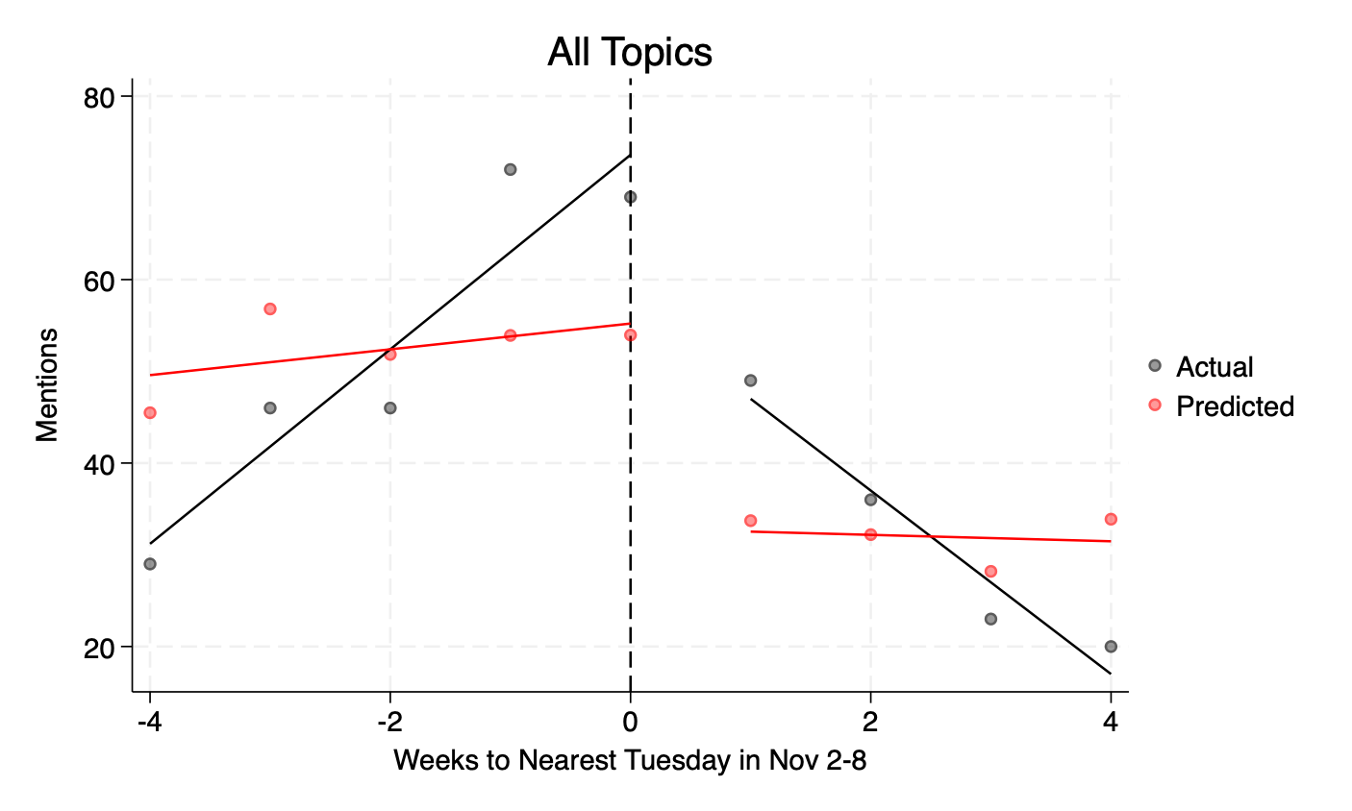 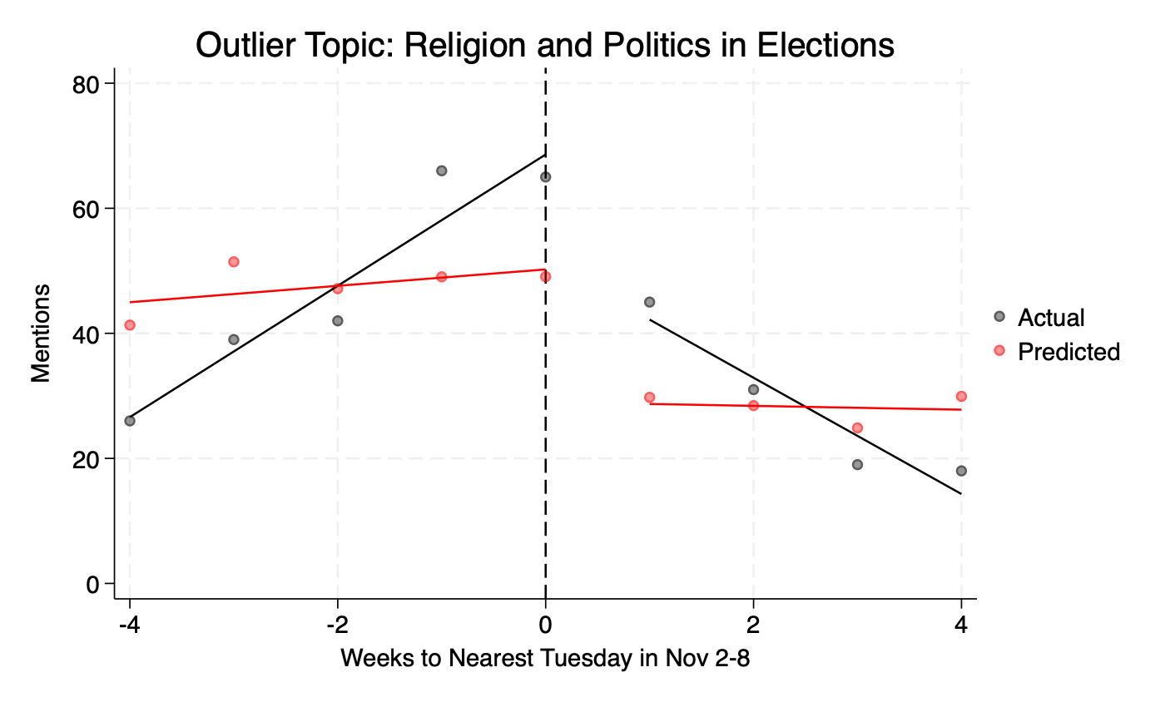 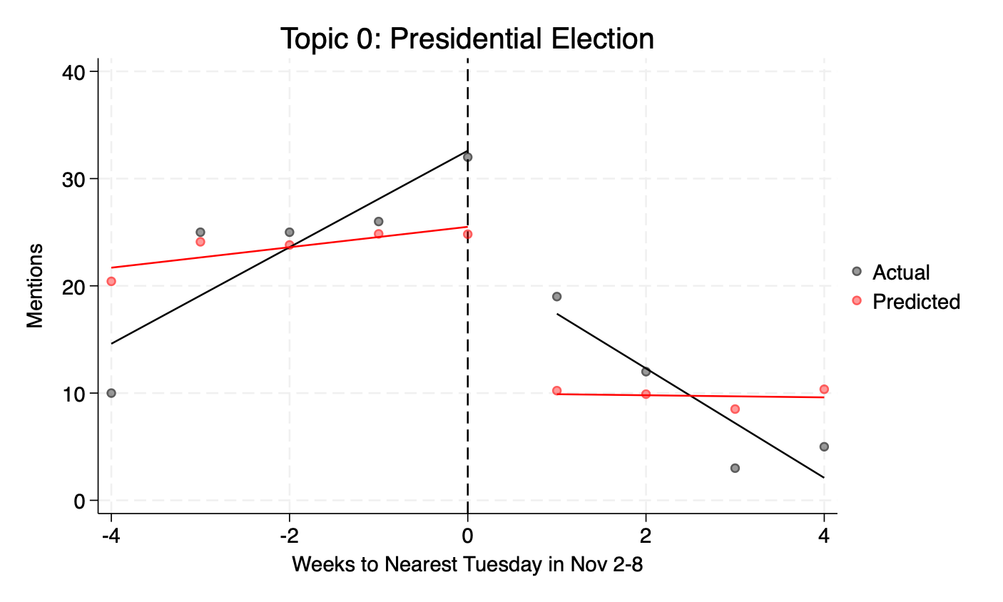 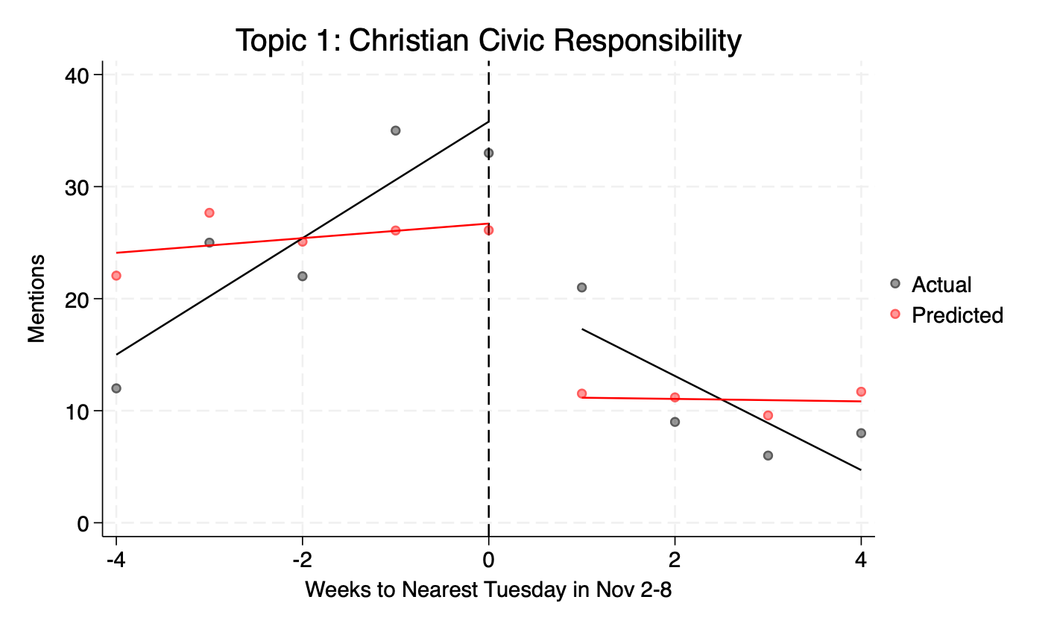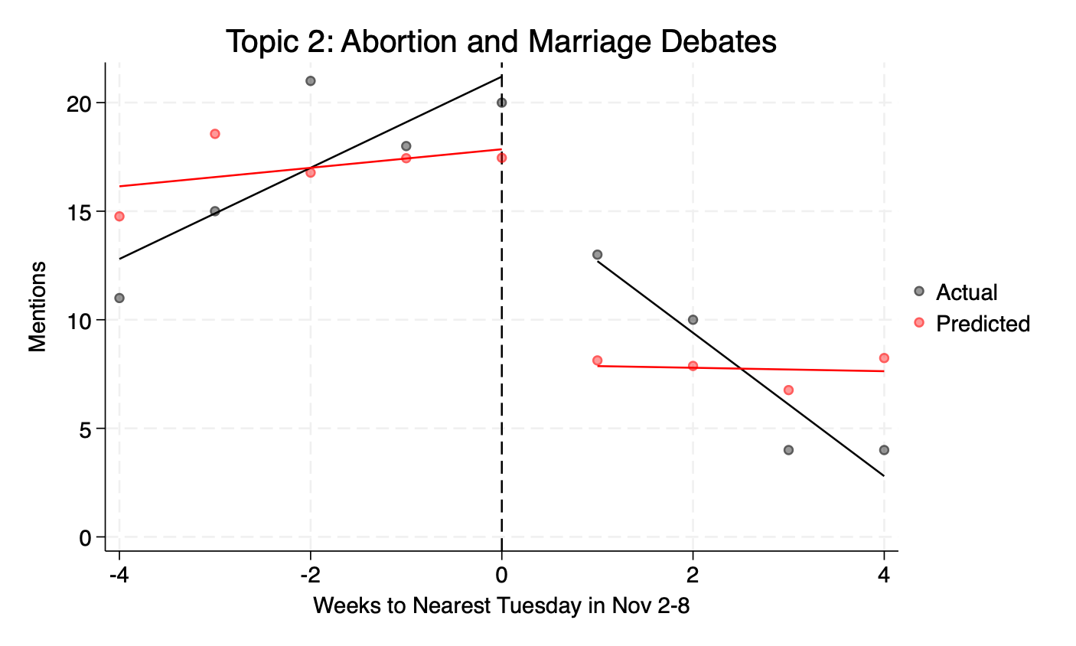 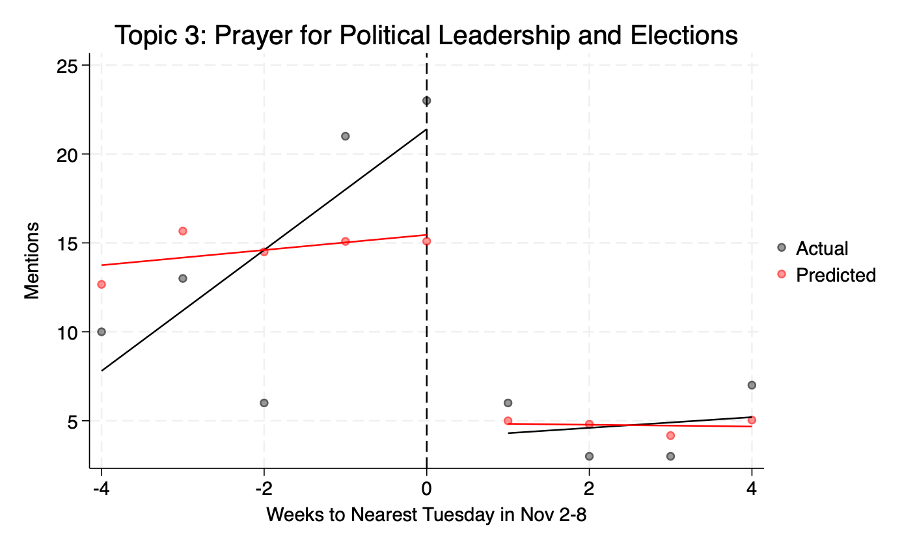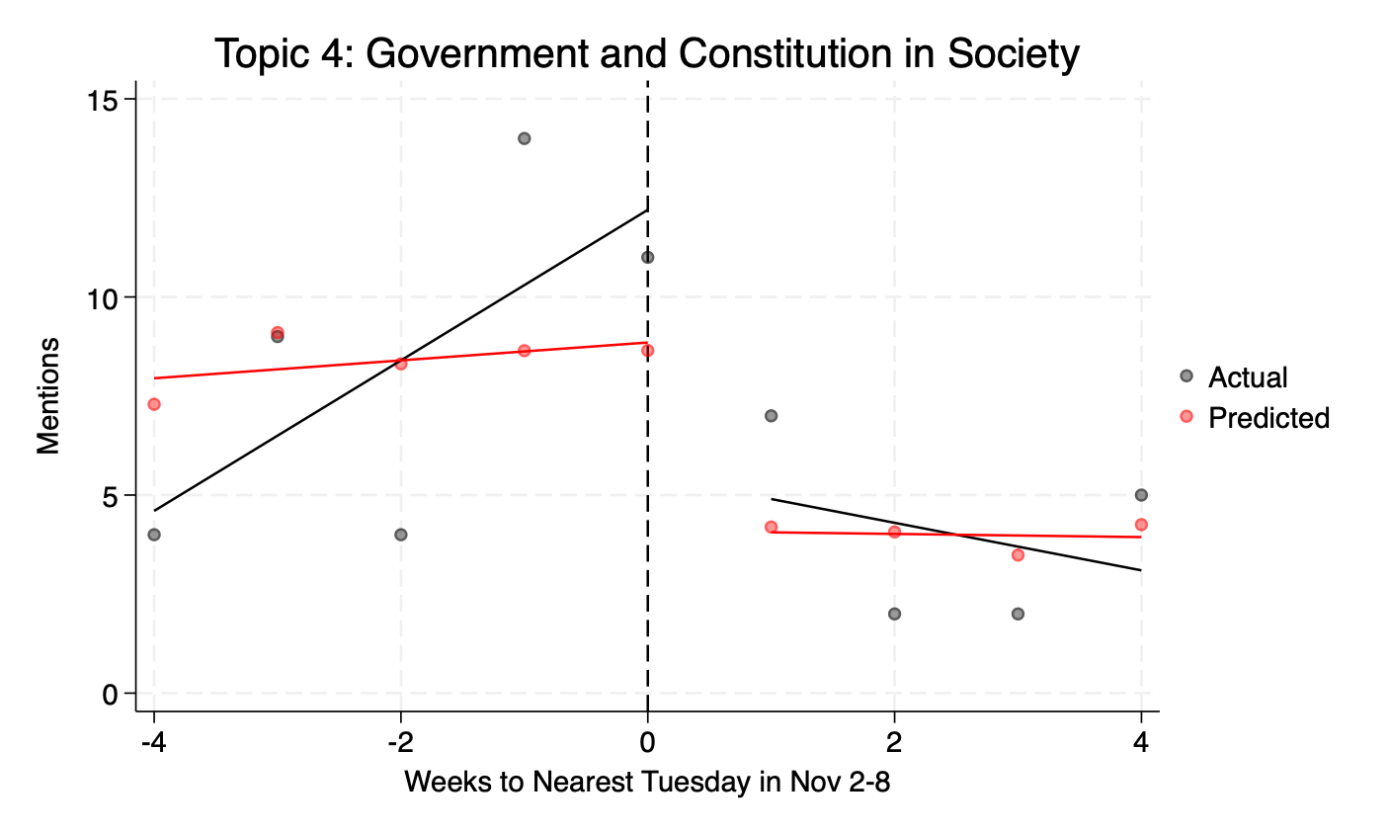 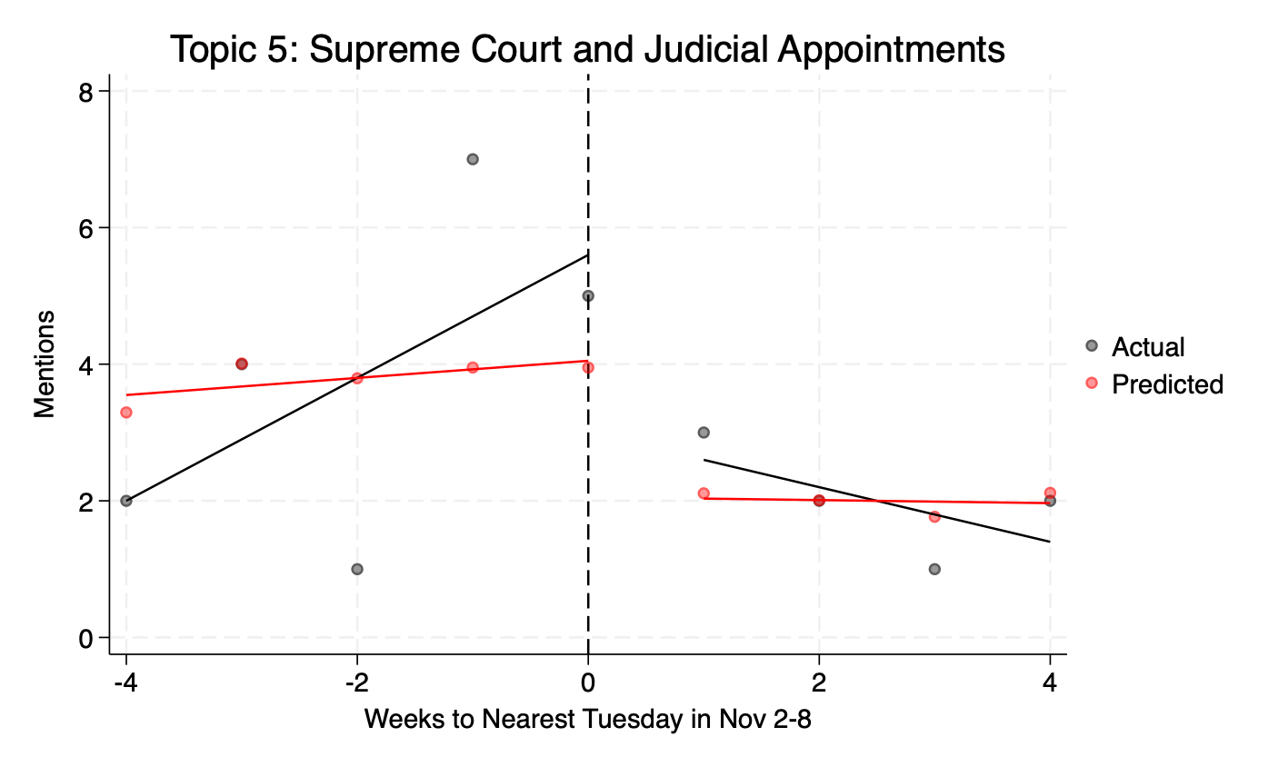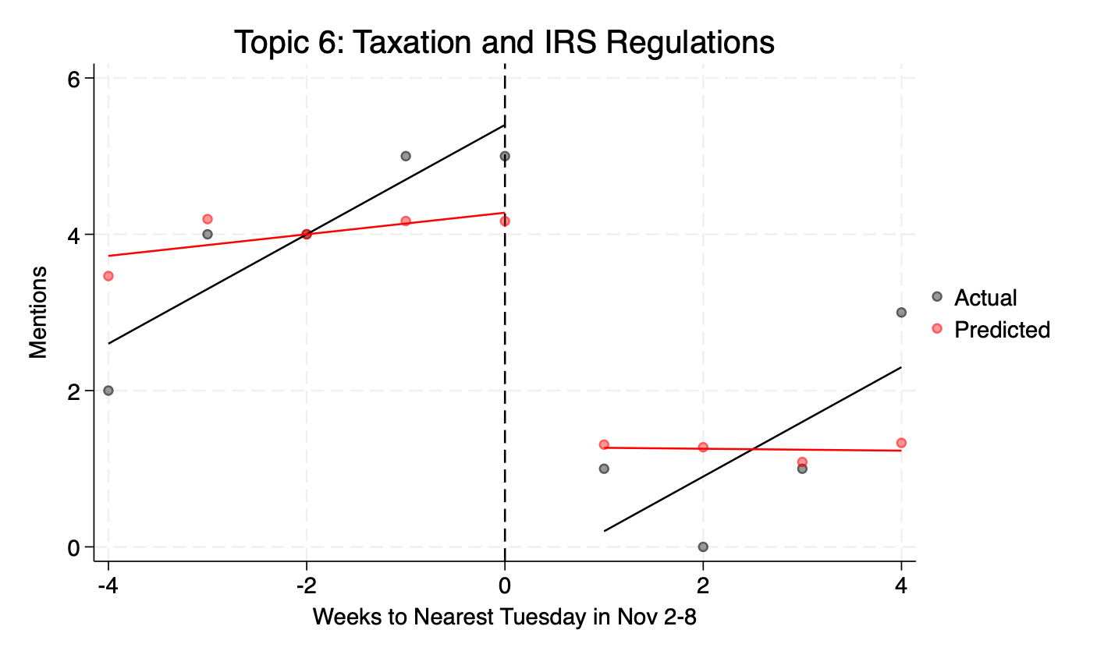 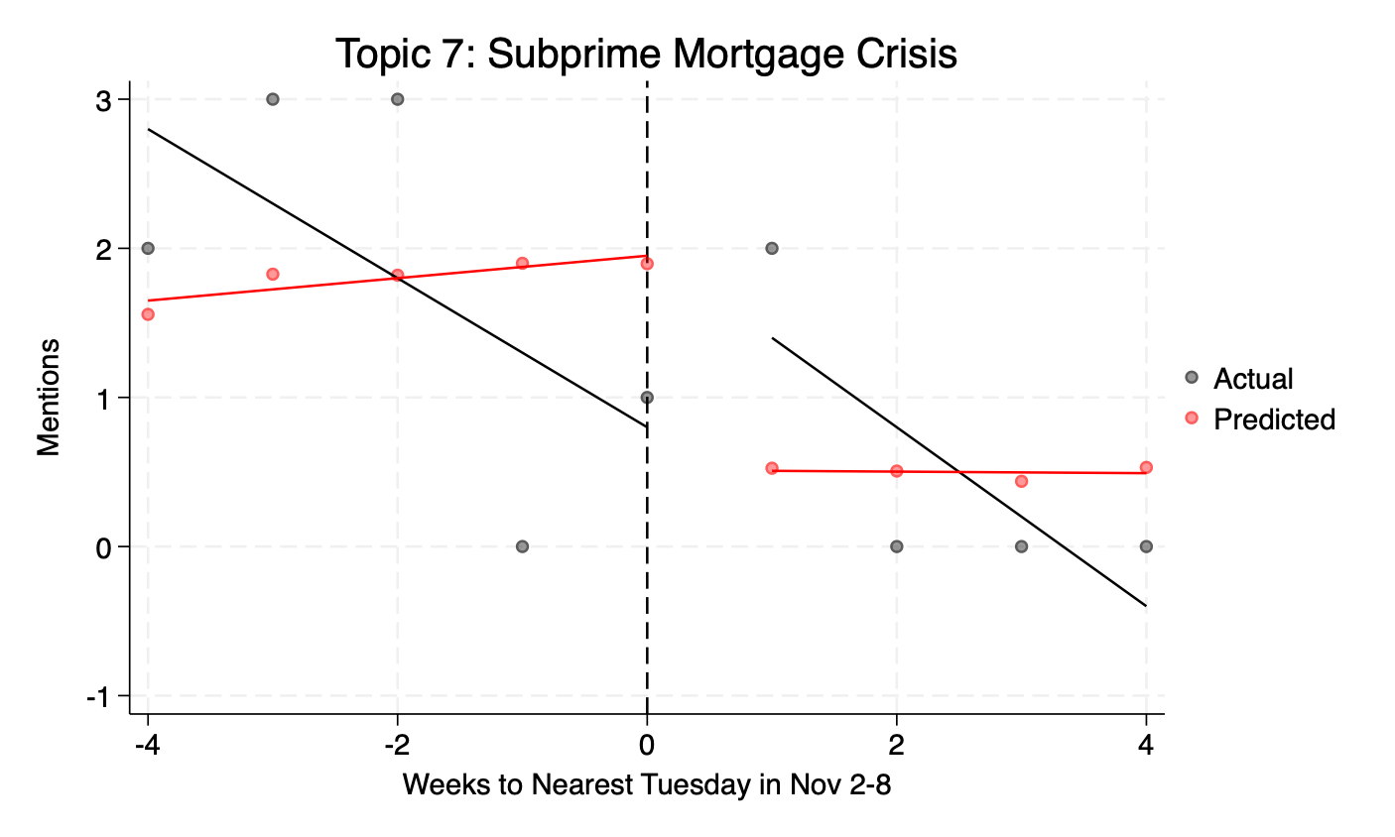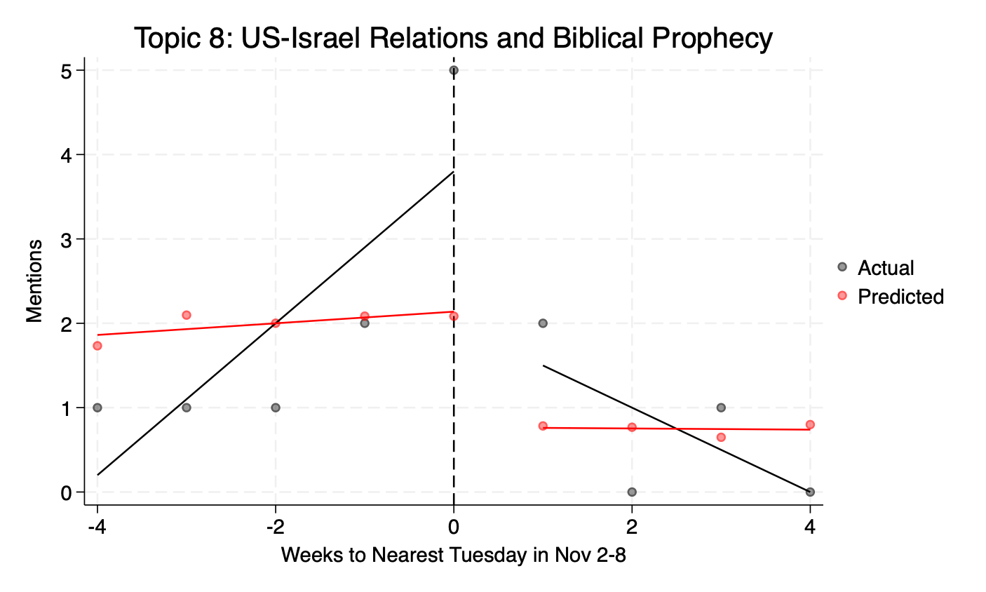 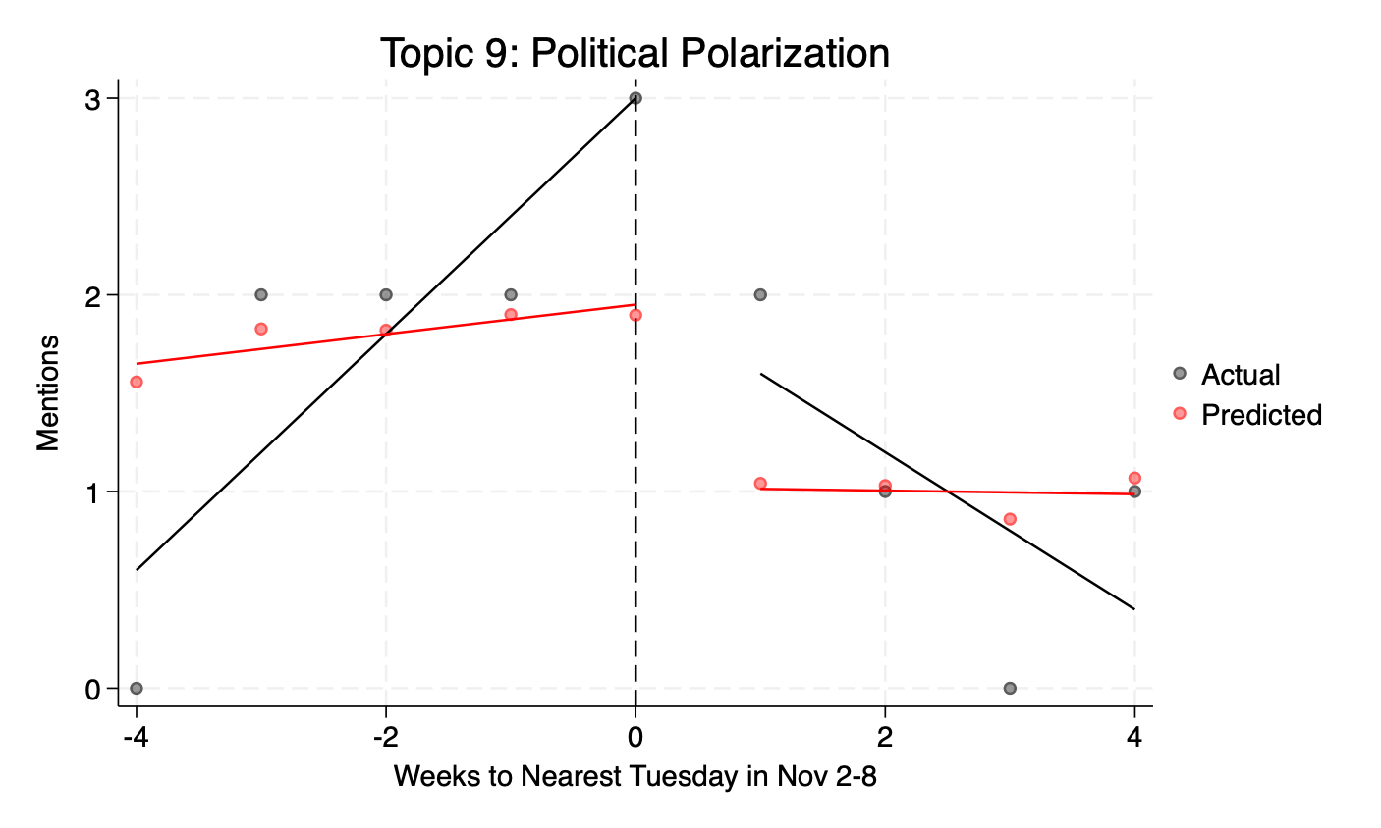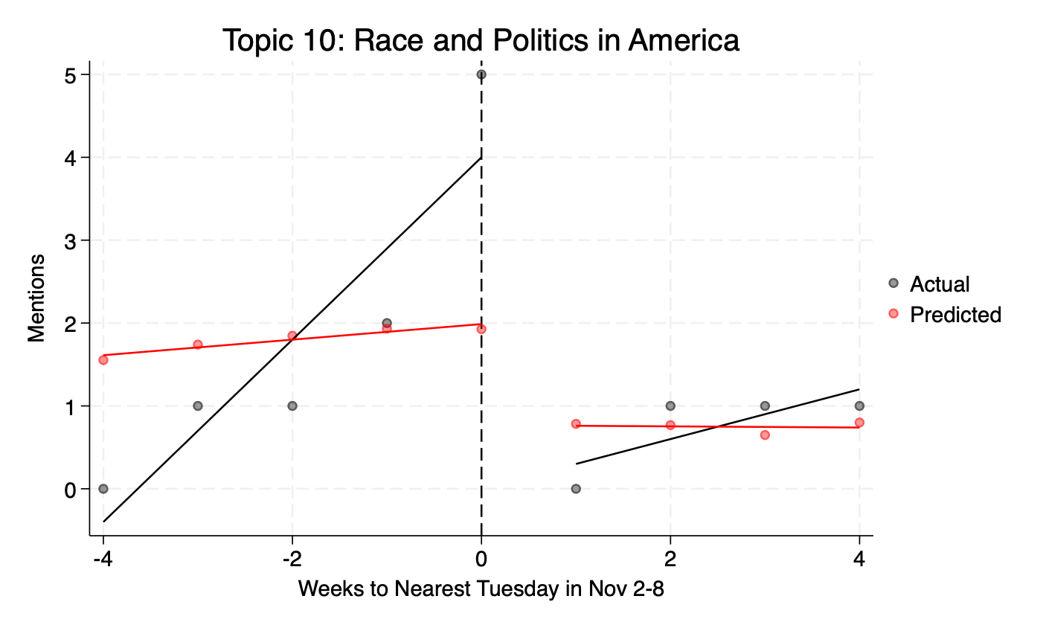 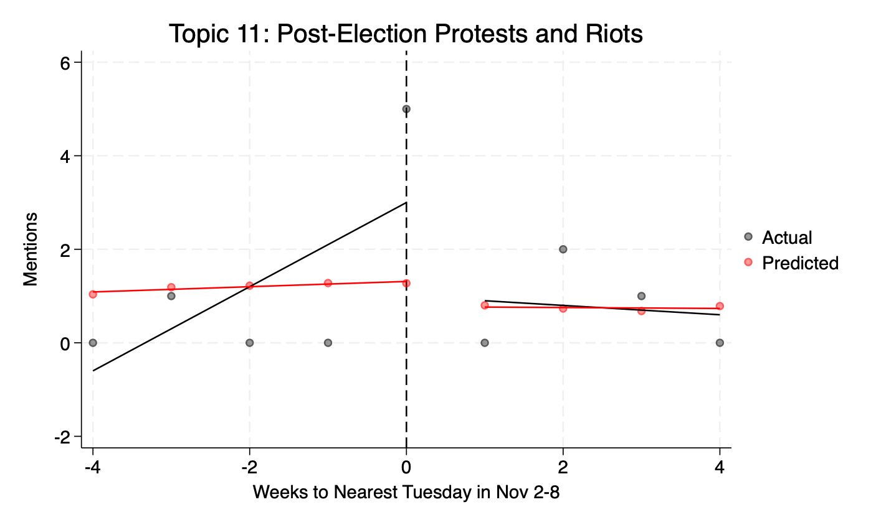

Outlier Topic: Religion and Politics in Elections

Top 10 words: god, election, people, nation, vote, can, from, president, political, would

Example sentences:

1. An extraordinarily costly plan was voted that is intended to address just the current crisis but it is not working yet as the President reassured us.
2. Finally, we have an important responsibility! III. The Responsibility We Face Light is no good to a blind man or a man who has his eyes closed! We must have our eyes open and take advantage of the light! What we do with the light we have is important. You and I have a responsibility to do what President Abraham Lincoln said at his second inaugural, with firmness in the right as God gives us to see the right Bro. Roy Harris writes that, the church should be the light that pierces the darkness of a nation in moral decline. It should travel down every available avenue to proclaim the principles of right and wrong to those inside and outside her walls.
3. Educate ourselves about where the candidates stand on the issues Again, I quote Bro. Roy Harris: Determining who we should vote for should not be a hard decision to make. This decision should transcend party identification, the latest poll, how our peers or family members plan or the suggestions of the media liberal or conservative. There should be something stronger guiding our thinking We should vote for candidates who give evidence in their lifestyle and stated position which most closely reflects our own biblical and personally held beliefs.
4. Not only are we in the midst of a world-wide pandemic but a hotly contested national election.
5. When this pandemic ends and it will end and this election is settled, we are can be guaranteed of these basic truths.
6. Some of you will think I am over reacting, but I am a voracious consumer of information. I have read blogs from gay activists who have stated their goals in plain language.
7. For those of you who are offended that I have attacked your political party, might I remind you that my political party is God alone.
8. So I personally believe that one of the most difficult tasks our new President will have during his first 4 years in office is not just trying to unite our nation but keeping it from falling apart.
9. It is absolutely historic. I am glad that our country has, at least in part, fulfilled some of Martin Luther King Jr.'s dream.
10. There is a church locally that is having some issues right now because of this election.

Topic 0: Presidential Election

Top 10 words: election, vote, god, president, country, tuesday, most, people, day, can

Example sentences:

1. We have a Presidential Election in 9 days that is very important and whoever is elected will have a difficult job ahead of them.
2. Guess what, on Tuesday, we as a nation and individuals who choose to vote, will go to the polls and elect our President for the next four years.
3. It seems that there are many ideas about who that leader should be.
4. A few weeks ago we saw the conventions as they call them of both our candidates.
5. As our two candidates came out to give their speeches, they had been prepped by hairstylists and make up people.
6. I heard an interview with one the surrogates and they said that if this guy is talking, he's lying.
7. How many believe that these two who are seeking the position of our leader will keep these promises that they are making to us.
8. I encourage you to vote on Tuesday.
9. I'm not sure if you know, but there's an election coming up this Tuesday!
10. If you can go back to 2016, after Trump defeated Clinton.

Topic 1: Christian Civic Responsibility

Top 10 words: vote, god, christians, christian, church, jesus, should, political, biblical, faith

Example sentences:

1. I've had numerous individuals who have asked me personally about how we should decide to vote, and who we should vote for and what a Christian's responsibility is in this case. Part of being a good Christian is being a good citizen and that means doing certain things set forth in Scripture.
2. That is not to say that you should not exercise your right to vote, you should be registered to vote and then go to the polls and vote. While there are issues that the Bible does not speak about, there are things that we can apply Biblical principles to. We have an obligation to take a stand for morality and righteousness and in my mind that would include being informed about what candidates stand for and voting for those who support Biblical values and virtues.
3. Let me quickly say, we have a Mormon running for President, he's running against a sitting Muslim, we've already seen what the Muslim does, a total disaster, we must choose between these two, to me the choice is clear.
4. And if we . . . the church are not careful, we too, just like so much of America, will be divided.
5. Samuel Adams put it this way, Let each citizen remember at the moment he is offering his vote that he is not making a present or a compliment to please an individual--or at least that he ought not so to do; but that he is executing one of the most solemn trusts in human society for which he is accountable to God and his country..
6. Politics are a part of a religion in a country as this, and Christians must do their duty to the country as a part of their duty to God...He will bless or curse this nation according to the course Christians take in politics.
7. By the way, that's why we should never discount the personal faith of a candidate.
8. It is your God given right and responsibility to vote.
9. When it comes to choosing a candidate,III. VOTE BIBLICAL PRINCIPLES NOT A POLITICAL PARTY.
10. That's why every believer ought to research the candidates.

Topic 2: Abortion and Marriage Debates

Top 10 words: abortion, marriage, life, issues, same, sex, child, unborn, woman, human

Example sentences:

1. Here are 10 questions you never hear a pro-choice candidate asked by the media: 1. You say you support a woman's right to make her own reproductive choices in regards to abortion and contraception. Are there any restrictions you would approve of? 2. In 2010, The Economist featured a cover story on the war on girls and the growth of gendercide in the world abortion based solely on the sex of the baby. Does this phenomenon pose a problem for you or do you believe in the absolute right of a woman to terminate a pregnancy because the unborn fetus is female? 3. In many states, a teenager can have an abortion without her parents' consent or knowledge but cannot get an aspirin from the school nurse without parental authorization. Do you support any restrictions or parental notification regarding abortion access for minors? 4. If you do not believe that human life begins at conception, when do you believe it begins? At what stage of development should an unborn child have human rights? 5. Currently, when genetic testing reveals an unborn child has Down Syndrome, most women choose to abort. How do you answer the charge that this phenomenon resembles the eugenics movement a century ago the slow, but deliberate weeding out of those our society would deem unfit to live? 6. Do you believe an employer should be forced to violate his or her religious conscience by providing access to abortifacient drugs and contraception to employees? 7. Alveda King, niece of Martin Luther King, Jr. has said that abortion is the white supremacist's best friend, pointing to the fact that Black and Latinos represent 25 of our population but account for 59 of all abortions. How do you respond to the charge that the majority of abortion clinics are found in inner-city areas with large numbers of minorities? 8. You describe abortion as a tragic choice. If abortion is not morally objectionable, then why is it tragic? Does this mean there is something about abortion that is different than other standard surgical procedures? 9. Do you believe abortion should be legal once the unborn fetus is viable able to survive outside the womb? 10. If a pregnant woman and her unborn child are murdered, do you believe the criminal should face two counts of murder and serve a harsher sentence?
2. I am thankful that 30 states have seen fit to adopt constitutional amendment's in support of traditional marriage and it is my hope that in the six states this year where same-sex marriage is being voted on that they will be defeated but whether they are or not there is only one definition of marriage that counts and it is the definition found in Genesis 2..
3. And last week, the latest act of arrogance and hubris by the Supreme Court, same sex marriage has been made the law of the land.
4. On Friday, the US Supreme Court ruled in a 5 to 4 decision that same-sex marriage is a constitutional right on the basis of the majority's interpretation of the Fourteenth Amendment.
5. Not only did they attempt to assume the role of God Almighty who has already declared that marriage is only between one man and one woman but five black-robed tyrants have overturned the votes of 50 million Americans in 30 states, demanding that we turn our backs on thousands of years of human history, reams of social science data, and most importantly, the clear teachings of Holy Scripture.
6. 66 oppose partial-birth abortions.
7. If we vote for someone who promotes abortion are we not an active participant in abortion?
8. There is at least one candidate for the highest office in the land who promotes abortion at every level in every place on earth. That person even endorses what is called partial birth abortion which is the slaughter of a fully developed newborn infant who was delivered feet first so that only the head is still inside the mother. That is nothing less than infanticide and it is fully promoted by one of the presidential candidates.
9. That candidate is also in favor of paying for abortion around the globe with US taxpayer dollars.
10. Teens can continue to go get an abortion without their parent's knowledge or consent.

Topic 3: Prayer for Political Leadership and Elections

Top 10 words: pray, need, leaders, prayer, praying, god, would, elected, president, election

Example sentences:

1. With the presidential election so near, this week I spent a lot of time this week thinking about praying about and researching that idea.
2. The New Congress: Pray that the congress would seek Godly advice in the way they legislate. Pray they would seek God's purposes and not their own. Pray that God would direct their course and actions in a way that would protect and benefit our country. Pray that they would see their need to trust God for leadership rather than their own understanding. Pray that they would seek Godly counsel and advice as they lead and legislate.
3. We look at this past election and many say we prayed hard and long and the election did not turn out the way we wanted.
4. This weekend has been declared a time of prayer and repentance for our country.
5. Will you join me as we pray for our country right before the elections?
6. It doesn't even say we have to like praying for them.
7. It does say that we are to pray for them if they do right or wrong, if they are Democrat, Republican or some other brand, if they are liberal or conservative or if they are moral or immoral.
8. We are going to vote for the next Supreme Commander in two days. It is no doubt one of the most important elections of our lifetime. And one of the reasons among many is the fact that the PRESIDENT is in charge of our military. I urge you all to take the time to pray and ask God how He would have you vote.
9. A lifelong friend Carolyn Byrd wrote and said, I don't think I have ever prayed this hard about an election.
10. In the past I have felt the need to pray for different elections but I have never felt so strongly the urge to pray, and pray fervently, for an election as I do for this one.

Topic 4: Government and Constitution in Society

Top 10 words: government, constitution, religion, people, form, united, states, democracy, believed, president

Example sentences:

1. Doesn't sound like John Jay believed that politics and religion weren't to mix.
2. Look at what President John Adams said, Our Constitution was made only for a moral and religious people...it is wholly inadequate to the government of any other.
3. Now we are into big government- Never before have more people been dependent upon government for having their needs met.
4. We, as a people, get the type of government we deserve.
5. Somebody has well said that Every nation gets the government it deserves. Is ours getting better or worse? Active citizens of the heavenly kingdom must not be passive citizens of the earthly kingdom. For the public business of the nation is the private business of every citizen.
6. Evidently our founding fathers understood that for they wrote in the preamble to our constitution that they were forming a new government: to establish justice, ensure domestic tranquility, provide for the common defense, promote the general welfare, and secure the blessings of liberty to ourselves and our posterity.
7. A government of the people, by the people, and for the people is an anarchy unless governed by eternal, self-evident principles, which are reflected in Scripture.
8. The Preamble of the Constitution says... We the people of the United States, in order to form a more perfect union, establish justice, insure domestic tranquility, provide for the common defense, promote the general welfare, and secure the blessings of liberty to ourselves and our posterity, do ordain and establish this Constitution for the United States of America.
9. The form of government on the United States as established by our Constitution is based upon the franchise. The legitimacy of our government comes from the consent of the governed, which means we vote our convictions and the government follows the will of the people as established by those we put into office, the legislative matters that we vote on directly in referendums, and on constitutional amendments such as those on which we will vote here in Arkansas.
10. Personally I believe that we are blessed to have the best form of government in the world, but I also know that it is not perfect. Unlike many people in the world, God has bless us with the ability to be involved in leadership selection. We have the additional advantage or opportunity to participate in setting moral standards and community rules of conduct.

Topic 5: Supreme Court and Judicial Appointments

Top 10 words: court, supreme, justice, justices, next, judges, appointed, president, laws, appoint

Example sentences:

1. It is ultimately more important who is appointed to sit on the supreme court than who will be in the president's cabinet positions.
2. They have the presidency and the United States Supreme Court.
3. As Paul notes, part of that ordering of society is the idea of the government's responsibility to execute justice.
4. Justice is a delicate issue.
5. Justice is often about perspective, I suppose.
6. In all those instances, there were those who debated, argued and fought and even died for justice sake.
7. As we reflect back on those times in history, dare any of us say that justice did not prevail?
8. The struggle for justice continues even today, as well it ought.
9. Survey the twenty-four hour news cycle and we can hear the cries of those who plead for justice.
10. Justice and justification are not necessarily the same thing.

Topic 6: Taxation and IRS Regulations

Top 10 words: tax, taxes, irs, churches, code, endorsing, figure, impose, from, pay

Example sentences:

1. In other words, governments are always going to impose taxes. And then they will figure out a way to impose more taxes.
2. Can we disagree with the policy? Yes. But we still have to pay our taxes.
3. With an election in the wings and some already voting, we hear an awful lot these days about taxes, and about what our government is doing right and doing wrong.
4. Liberals favor such regressive taxes because they believe government itself is the greater good. Not people.
5. Unsurprisingly, just a day after the election, the group ironically calling themselves Citizens for Responsibility and Ethics in Washington urged the IRS to investigate whether the United States Conference of Catholic Bishops has engaged in prohibited activity in violation of federal tax law.
6. It is called the California Wealth and Exit Tax.
7. In other words, if signed by the governor, even if you wanted to leave the state this bill would impose an annual tax on a taxpayer's worldwide wealth for 10 years.
8. The wealth tax proposal includes an exit tax to ensure that no one escapes the loving embrace of the California Franchise Tax Board.
9. For that reason, the guidelines for churches in particular, require that it not to endorse or oppose particular political candidates per se.
10. However, a church can openly speak to the issues and policies advocated by a political party or its candidates, while still not openly naming, endorsing or opposing particular candidates.

Topic 7: Subprime Mortgage Crisis

Top 10 words: money, trillion, banks, loans, fannie, freddie, couldn, free, mac, mae

Example sentences:

1. Everyone, even the 'above the common folks' Congress, will have to give up some of our wealth.
2. Like never before, our politicians are promising us free money. They are promising to spread the wealth around. They are promising, as our right, all sorts of entitlements.
3. According to Terry Jones of the Investor's Business Daily posted Wednesday, September 24, 2008, President Carter signed the Community Reinvestment Act in 1977, which pushed Fannie Mae and Freddie Mac to aggressively lend money to low-income communities.
4. When Clinton got into office, he supercharged the process. He put in place new rules and regulations, which gave Fannie Mae and Freddie Mac extraordinary leverage, allowing them to hold just 2.5 of capital to back their investments, vs. the 10 required for banks.
5. With government guarantees and government incentives in place, banks made loans to people that required no money down and no verification of income.
6. People who couldn't afford it, were given extraordinary loans, and by 2007, Fannie and Freddie owned or guaranteed nearly half of the 12 trillion U.S. mortgage market.
7. When President Bush and others began to warn congress of an impending crisis, most congressmen ignored it, because Fannie Mae and Freddie Mac were financing 384 of their campaigns to the tune of 200 million over the last 20 years.
8. Free money was available for the taking. All went well as long as housing prices kept going up.
9. If a person couldn't pay their mortgage, which many couldn't, no problem! Just foreclose on the property and sell it for more than what was owed.
10. Banks were making money hand over fist with these subprime loans, and it worked as long as the housing prices kept going up.

Topic 8: US-Israel Relations and Biblical Prophecy

Top 10 words: israel, nation, america, curse, land, fate, jewish, bless, shall, god

Example sentences:

1. For some time I have focused on the condition of America and the destructive direction we are moving in as a nation.
2. America's view of responsibility has suffered deterioration since its inception. Erosion accelerated through the latter half of the 20th century and first dozen years of the 21st century.
3. We decree that the land of Israel shall not be divided. Out of heartfelt conviction we passionately support the Jewish state of Israel and see in it God's promise and fulfillment of the covenant between the Jewish people and the land itself.
4. And I know me. There will probably be times of weakness when I will worry about the fate of our nation.
5. What about our nation's relationship with the nation of Israel?
6. In Genesis 12:1-3 Yahweh the LORD said to Abram, go from your country, your people and your father's household to the land I will show you.
7. If God is going to bless the nation that blesses Israel and curse the nation that curses Israel I think it's pretty important to be a nation that blesses the nation of Israel.
8. I fear our country is in a downward spiral that will quickly result in our destruction as the nation we once knew.
9. The majority of Americans are swallowing it hook, line and sinker. Already, we are more than 20 years beyond the average age of the world's great civilizations.
10. We continue to fight a war on terror with an enemy that is hard to identify and even harder to trace, and we face aggressive nations having the capabilities of nuclear weapons.

Topic 9: Political Polarization

Top 10 words: divided, better, division, divide, like, country, divides, weather, war, sets

Example sentences:

1. It may not be 1970 but we are just as divided today over the wars in Iraq and Afghanistan as we were about the war in Vietnam then.
2. There was a sharp division among people.
3. But we're seriously divided in our country.
4. Nothing divides like politics, because nothing divides like fear.
5. The lack of civility and fear tactics has led to an ideological divide and a shaken up citizenry.
6. This country is in a mess. The country is divided not only by political parties but by moral objections. Divided by where God stands in our nations fiber of belief. The right to life weather it is in the mother's womb or weather we will develop a merciful way of killing people after they reach a age of un-productivity.
7. We truly live in a divided America, two sets of ideology, two sets of convictions.
8. And though there can only be so much division on an electoral map, we have seen how division can grow even still.
9. When was the last time any of our elected officials said anything about the great divide that exist between the haves and the have not’s.
10. America is becoming a divided nation because of man's politics and it is a scary place to be.

Topic 10: Race and Politics in America

Top 10 words: black, american, white, african, president, blue, first, male, cycle, red

Example sentences:

1. Only now it's not just white and black, it's white, black, and Hispanic.
2. But I do want to say this for the record, I am rejoicing that an African-American is going to be in the White House.
3. The fact that we could have our first African American president, while history making, is NOT a good enough reason to vote for a person. That is simply the outside package. Neither is the fact that we could have our first woman vice-president a good enough reason to vote for a candidate. Race and gender are merely exterior packaging. They tell us nothing about the interior of the people who may lead our country.
4. Some voted for Obama simply because he is black and that is as racists as the one who didn't vote for him because he is black.
5. There are some people who hate our president just because he is black and would assassinate him if they could.
6. The soon approaching presidential election is not just about racism; it is also about classes.
7. We have our first African American president. Whether you like it or not, he is still the President of the United States of America.
8. I look forward to the day when we will have a President who is not a white male not that there's anything wrong with being a white male!
9. Imagine a day when we can be served by a white woman, or a black male or black female, or a Chinese American, or a Puerto Rican American, or a Mexican American.
10. Five of the 16 are African American.

Topic 11: Post-Election Protests and Riots

Top 10 words: burning, streets, flag, flags, protester, protesting, rioting, lack, protest, election

Example sentences:

1. People are protesting in the streets with signs saying that President-elect Trump will not be their president.
2. People are picketing the streets in protest of the election.
3. That candidate has gone on record as saying that he would not wear the America flag on his lapel, because he did not want to appear as if he were taking sides.
4. She was one of those marching in protest to the election results.
5. We have actually had rioting in the streets, we have had people burning American flags.
6. I have watched the protests, and the anger these folks have displayed shows they lack the tolerance they preach, and they lack the joy they should have because they get to live in the United States of America!
7. I saw some of the protestors given an open mic by a reporter to articulate their angst so folks could understand what exactly was troubling them.
8. The protester offered up vile profanity. I saw another young female protester who articulated her fears and desires with a level of calm and intellect. I may not have agreed with her, but I was willing to empathize with her point and listen.
9. People are foolishly rioting because they are anxious about what the next administration will or will not do.
10. I don't know how many of you have seen on the news about the riots and flag burning and civil disobedience that have taken place since Donald Trump won the Presidency.